**Title: The fastest growing and most destructive fires in the U.S. (2000-2020)**

**Authors:**

**Affiliations:**

**One Sentence Summary:** In just two decades, the number of homes exposed to fast fires more than doubled.

**Abstract (162/125 words max.)**

Most of the destructive and deadly wildfires in U.S. history were also fast. This study reconstructs the daily growth for more than 95,000 fire events (2000-2020) across the conterminous U.S. using FIRED, a satellite-derived fire event database. Nearly half of U.S. ecoregions experienced “fast fires” (growing >1620 ha per day; N = 1616), which were responsible for the vast majority of both structures destroyed (75%; 80,321) and suppression costs (59%; $18.2 billion). Maximum daily fire growth rate (FGR) primarily (83% of events) occurred within the first five days of an event, and the faster the fire, the bigger the fire (adjusted R2 = 0.97). Within just two decades mean FGR increased by 27% across the western U.S. In tandem, the number of homes exposed to fast fires (< 1 km from a fire perimeter) more than doubled. Given recent devastating wildfires we need to understand fast fires to better inform suppression efforts and to better prepare communities.

**Main Text: (~3000 words, without figure/table captions)**

Some of the most deadly and destructive wildfires in contemporary U.S. history have occurred in recent years, with most having a common characteristic of extremely rapid growth. The 2018 Camp fire killed 85 people and destroyed over 16,000 homes in a matter of hours. The 2018 Martin fire burned 425,000 acres in 4 days in northern Nevada. The 2021 Marshall fire, driven by winds over 100 mph, burned more than a thousand homes and is now the most destructive wildfire in Colorado history. By current count, the 2023 Lahaina fire killed 115 and has likely destroyed thousands of structures becoming the nation’s most deadly wildfire in a century. The modern era of ‘megafires’ is often defined based on size of events (Tedim et al. 2018), but should be defined based on speed because this is what makes wildfires more deadly and destructive. While big fires contribute to toxic air quality [(Johnston et al., 2021)](https://www.zotero.org/google-docs/?0iKmne), fire speed matters more for infrastructure risk and evacuation planning [(Balch et al., 2017; Mietkiewicz et al., 2020)](https://www.zotero.org/google-docs/?UALSjl).

While the scientific community has explored trends in extreme fire size [(Joseph et al., 2019; Nagy et al., 2018)](https://www.zotero.org/google-docs/?g1vVJf) and burn severity [(Parks and Abatzoglou, 2020; Picotte et al., 2016)](https://www.zotero.org/google-docs/?9kIi7x), as well as documented increasing burned area across the western US [(Dennison et al., 2014a; Higuera et al., 2021)](https://www.zotero.org/google-docs/?lt9wQE), we know relatively little about when and why fast fires  occur at regional or national scales. We know that most area burned in extremely large events is from single day growth events, which are driven by extreme fire weather, and these SDGEs are predicted to more than double with 2C warming (Coop 2022). Humans also happen to ignite fires in areas with lower tree cover, closer to structures (Nate M. 2020) and during times with more extreme fire weather (Hantson 2022), resulting in more destructive fires (Syphard et al 2022). Recent observational evidence is corroborated by  empirical models [(Rothermel, 1972)](https://www.zotero.org/google-docs/?dbltTm) that derive relationships to predict fire growth [(Andrews, 1986)](https://www.zotero.org/google-docs/?ySaFNC), as well as developing physical relationships to drive landscape fire simulations for individual events [(Perry, 1998; Sullivan, 2009a, 2009b)](https://www.zotero.org/google-docs/?klch0r). Such fire behavior models inform wildfire risk models which suggest that the most deadly and damaging wildfires are also some of the fastest [(Coen et al., 2018; Maranghides et al., 2021)](https://www.zotero.org/google-docs/?R89DH3) (ref from Pyne). How fast fires burn also affects burn severity, spatial complexity [(Falk et al., 2011; Sugihara et al., 2006; Wang et al., 2021)](https://www.zotero.org/google-docs/?r9Eoea), and synchronicity [(Iglesias et al., 2022)](https://www.zotero.org/google-docs/?bE97ed). Yet, we do not know the patterns, drivers, and consequences of fast fires on a national scale.

Fire suppression policies, the proliferation of invasive species, climate change, and anthropogenic ignition patterns have fundamentally altered the fire-evolved landscapes of post-colonial America [(Balch et al., 2017, 2013)](https://www.zotero.org/google-docs/?NxLZXh). Moreover, the expansion of the urban footprint [(Leyk et al., 2020a)](https://www.zotero.org/google-docs/?mD6piT) has placed tens of millions of homes squarely into this contemporary fuel matrix. The rapid expansion of this footprint has occurred largely without regard for wildfire risk, either through building policies or comprehensive community planning [(Kramer et al., 2021)](https://www.zotero.org/google-docs/?DNl4Lp). As a result, nearly 60 million homes in the US were threatened by a wildfire between 1992 and 2015 [(Mietkiewicz et al., 2020)](https://www.zotero.org/google-docs/?qIsaf6), a number that likely increased substantially in the intervening years due to record fires in California, Oregon, and Colorado. Wildfire risk models that are currently used at a national scale are based on probability of occurrence and area burned, intensity, or severity [(Dillon et al., 2015; Finney et al., 2011; Haas et al., 2013; Haight et al., 2004; Iglesias et al., 2022)](https://www.zotero.org/google-docs/?A11tUs), rather than how fast wildfires could move. The lack of attention on fire growth is a critical risk assessment gap, particularly given the rapid expansion of the Wildland Urban Interface into the areas with the greatest probability of wildfire [(Radeloff et al., 2018; Rao et al., 2022)](https://www.zotero.org/google-docs/?cfdA3x). If we are to fully understand fire risk as it relates to property and lives we must understand how fast fires move.

Our lack of understanding is linked to our lack of national data on fire growth rates across events. Recent data on individual fire events and how they progress, coupled with fine-grained settlement data enable us to explore how fast fires move at a national scale and residential exposure. We developed a fire event delineation (FIRED) perimeter dataset for over 93,000 fire events  [(Balch et al., 2020b)](https://www.zotero.org/google-docs/?LNlnuU). Because this dataset is derived from daily burn date estimations from the MODIS burned area product (Giglio et al 2018), it enables calculation of daily fire growth rate (FGR) and investigation of how fast fires grow on a daily basis at a national scale. It is important to note that FGR derived from satellite-detected burned area on a daily basis is different, but certainly related to, how fast an actual burning fireline moves on the ground. Settlement data have also become available to measure long-term trends of development over long time periods at fine resolution [(Leyk et al., 2020b)](https://www.zotero.org/google-docs/?PB9C6U). The Historical Settlement Data Compilation of the US (HISDAC-US) [(Leyk and Uhl, 2018; Uhl et al., 2021)](https://www.zotero.org/google-docs/?RAKci1), which is derived from over 200 million property and housing records, provides novel insights into the spatial distribution of built land. Moreover, we are able to consider simultaneously the effects of social-environmental extremes [(Balch et al., 2020a)](https://www.zotero.org/google-docs/?y2yOcT), a critical framework for understanding and defining megafires. Government records during suppression activities (ICS-209-PLUS) enable us to further explore the societal consequences of wildfires by providing documentation on how many homes were threatened or destroyed during fire events [(St. Denis et al., 2020)](https://www.zotero.org/google-docs/?t90buU). The aggregation of ICS-209 reports provides the best available information on why U.S. wildfires are costing so much.

Given the critical need to understand fast-moving wildfires and the tens of millions of homes that are in the way, we analyze megafires in the context of their speed and damage to homes. We: i) document the fastest growing fires in the U.S. (2000-2020), ii) relate daily fire growth rate (FGR) with societal impact (homes damaged or destroyed), and iii) explore the trends in how many homes were exposed to fast fires (growing >1620 ha/day) over the past two decades.

**The fastest growing fires in the U.S.**

Fast growing fires occurred in most ecoregions, with the fastest fires occurring predominantly in the western U.S. (**Figure 1**). Daily fire growth rates were highly variable, with the average fire growing at a rate of 255 ha/day. Maximum FGR ranged from 21-214,200 ha/day, often an order of magnitude greater than the average FGR across the entire event (**Figure S1**?). The maximum FGR accounted for over a third of the area burned across the U.S. (Supplementary Table 1). As much as 38% of the area burned across the conterminous U.S. burns on the maximum day of growth, and as much as 63% in some landcover types in some ecoregions (e.g., savannas in N. American deserts; **Table SX**). The maximum daily FGR is very strongly associated with final fire size across landcover types (**Figure S1**?), with the log-log relationship suggesting that it follows a power law distribution (log-log relationship for all events: coefficient = X.X, adjusted R2 = 0.97). The importance of this is that extreme fire weather on individual days is driving fire growth and has consequences for suppression efforts [(Goss et al., 2020)](https://www.zotero.org/google-docs/?pgWMBi). Moreover, more than 90% of events last no longer than 20 days (**Figure S2A**?), and 83% of events reach their maximum growth rate within five days, across all ecoregions (**Figure S2B**?). Many fire modeling efforts at regional to national scales model fire activitybehavior  at on at monthly to yearly timescales (Joseph et al 2019; Moritz 2012). This result highlights the need to model fire behavior and its predictors on daily to hourly time scales, particularly to model the occurrence of extreme meteorological events and their ability to drive rapid fire growth [(Wang et al., 2021)](https://www.zotero.org/google-docs/?AQTd5j). We also found that mean and maximum FGR are variable by landcover and ecoregion, but the fastest growing fires were typically in the grasslands and savannas of arid ecoregions. The top 10 fastest fires were in grasslands and highlights the fine, flashy fuels and low wind friction in these ecosystems (Table 1). Six highlighted wildfires show how fast fires can grow (Figure 2).

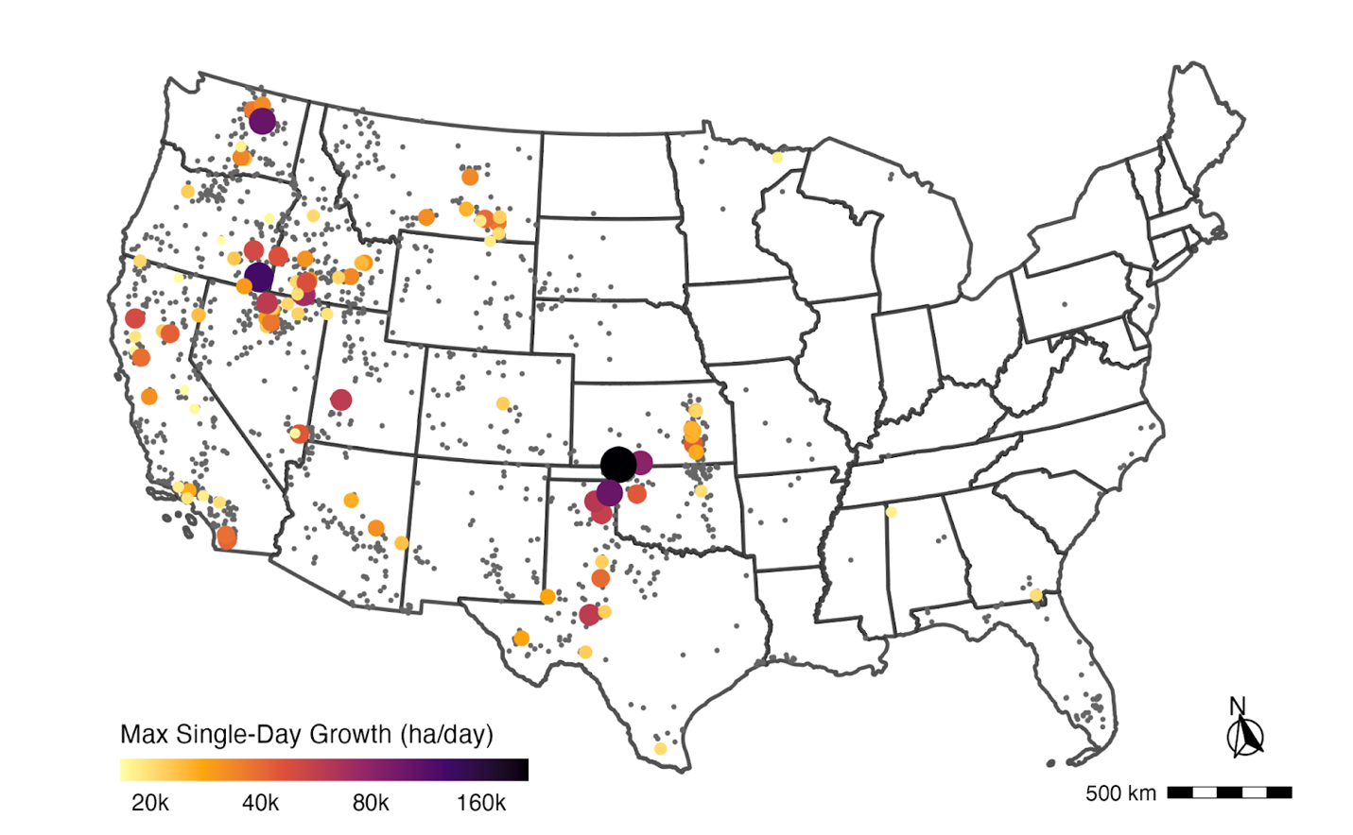

**Figure 1.** Locations of all recorded fast fires (2000-2020, N = 1,638) in the Conterminous United States (CONUS) with the top 100 fastest fires scaled in color and size by their maximum single-day fire growth in hectares/day. The fastest fires occurred primarily in the western United States and in the southeastern plains (Texas and Oklahoma), but across a wide range of ecoregions and fuel types.

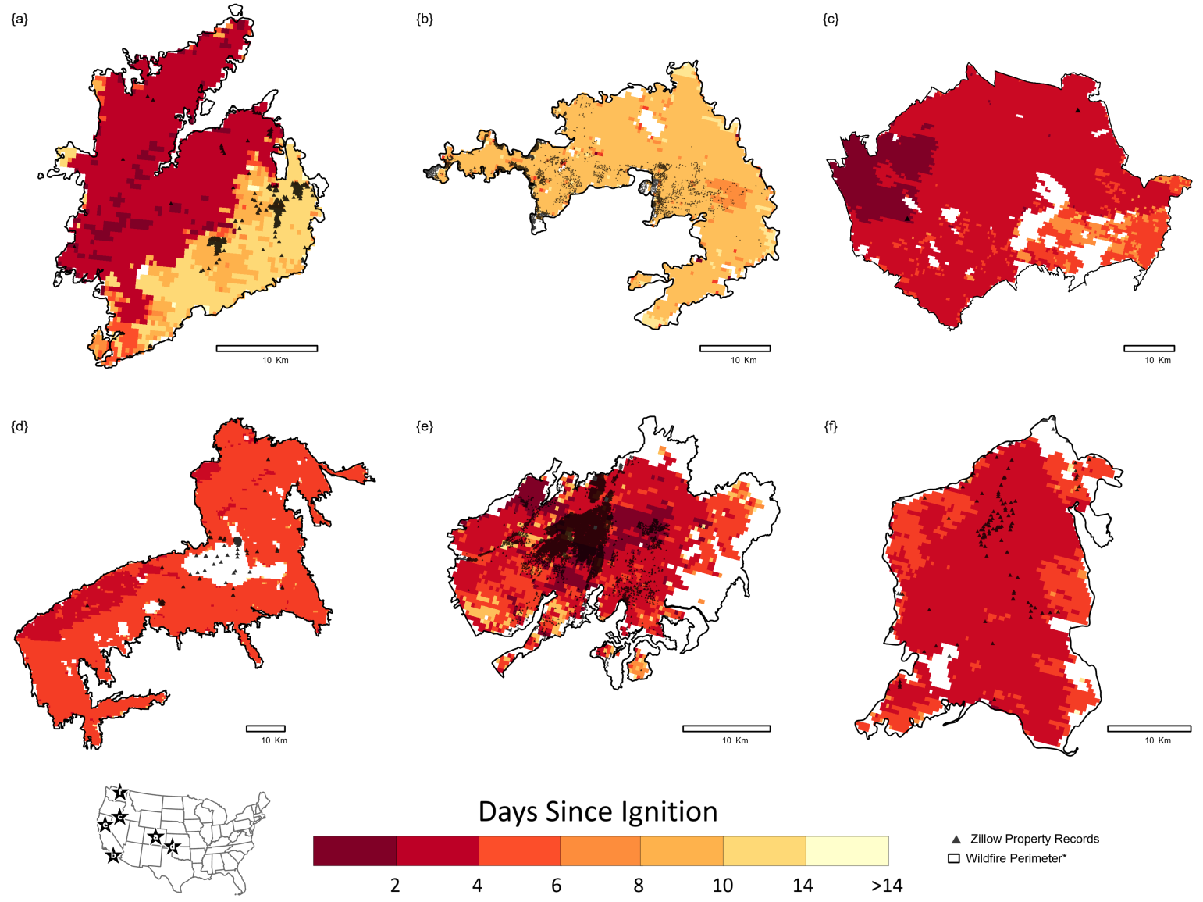

**Figure 2.** Selection of the top 100 fastest wildfire events (2000-2020) showing burn perimeters (black outline) from the Monitoring Trends in Burn Severity (MTBS), Zillow ZTRAX built-up property locations (black dots), and daily fire progression from the FIRED product. **(a)** Hayman Fire, CO (2002); one of the fastest recorded fires in Colorado with a maximum single-day growth of 22,045 ha and 133 destroyed homes, burning primarily in timber fuels. **(b)** Witch-Poomacha Fire, CA (2007); one of the most destructive fast fires, single-day growth of 38,638 ha and destroyed 1,141 homes, **(c)** Long Draw Fire, OR (2012); the fastest wildfire event in the state during the study period, **(d)** OKS-Starbuck Fire, OK (2017); the fastest recorded wildfire in the database with a maximum single day growth of 214,207 ha, **(e)** Camp Fire, CA (2018); became the deadliest and most destructive fire in California state history, destroying 13,983 homes in the town of Paradise, CA, and recording a maximum single-day growth of 21,680 ha, **(f)** Cold Springs Fire, WA (2020); The fastest fire recorded in the state and one of the fastest in 2020 with a maximum single-day growth of XX and part of the most destructive complex fires in state history (Cold Springs, Whitney, and Pearl Hill).

**Fast fires are also the most destructive and deadly**

While there has been substantial focus on megafires, defined primarily by their size [(Stephens et al., 2014)](https://www.zotero.org/google-docs/?utOyaO), we delineate a critical physical metric that links directly with impact, i.e., fire growth rate. Treating wildfires as social-environmental extremes [(Balch et al., 2020a)](https://www.zotero.org/google-docs/?vnCImW) and defining a subset of events based on their physical behavior and destructive impact advances our understanding and ability to prepare for such events [(Cook, 2021)](https://www.zotero.org/google-docs/?oLnYdL). Regression tree analysis indicates that fires growing faster than 1620 ha/day damage or destroy a large number of structures (residual mean deviance = 2.39; **Figure S3**). This speed corresponds to the 97th percentile of maximum fire growth registered between 2000 and 2020, representing 1,616 events/60,012 total events and 60.1% of the burned area in the FIRED record. We, therefore, define “fast fires” as events that grow more than 1620 ha per day. These fast fires account for 89% of the structures damaged or destroyed during fires. Our results document that 58 of the 85 level 3 ecoregions in the continental U.S. have experienced fast growing fires (**Figure 1**), representing an area of ~3,780,000 square-kilometers or 49% of CONUS land area. According to the ICS-209-PLUS (2000-18; add St. Denis ref), fires over 1620 ha/day threatened 906,595 structures (71% of total) and resulted in $11.68 billion of suppression expenditures (60% of total). Moreover, 59,326 structures were destroyed (87% of total), and 40,191 were damaged (92% of total) across this time-period during fast fire events. This subset of fires represents a significant impact to society, including accounting for 380 fatalities (83% of total) and 5010 injuries (44% of total).

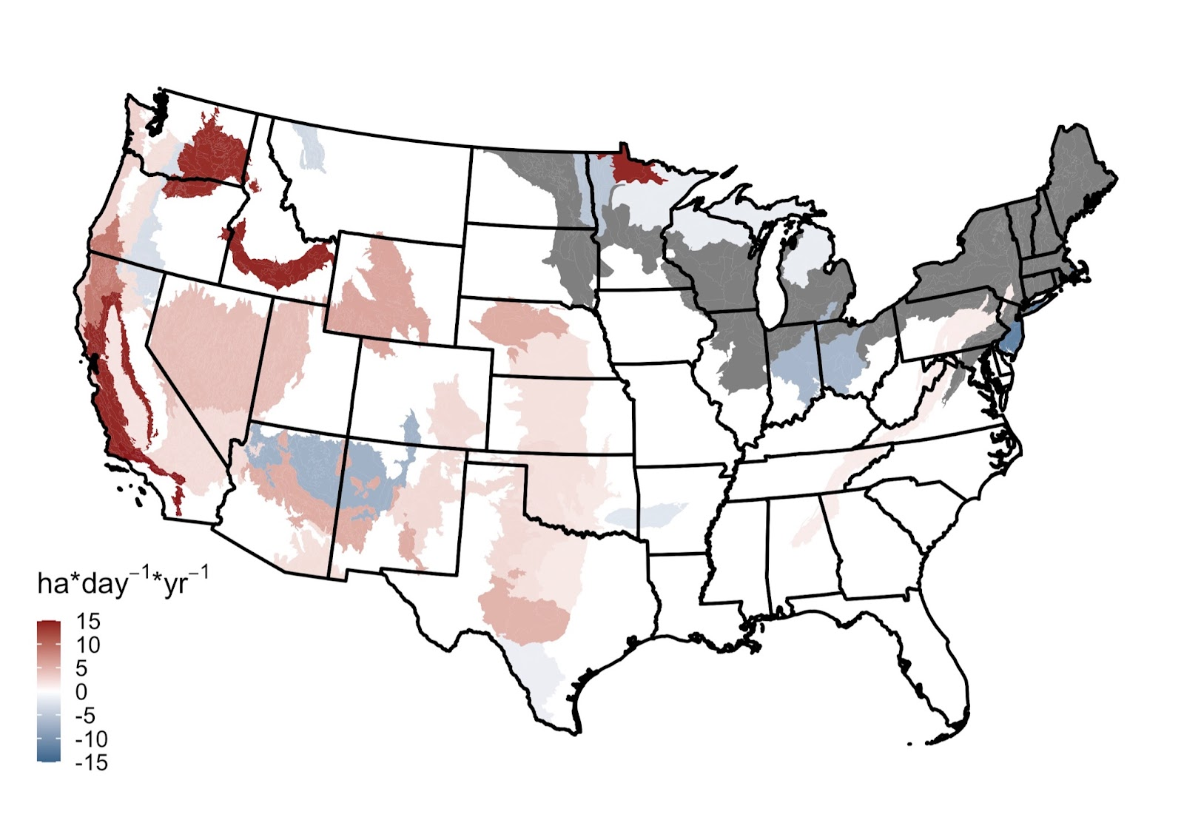

**Figure 3:** Temporal trends in maximum fire growth on a given day for events longer than four days per EPA ecoregion level IV (2001-2020). Statistically-significant positive and negative regression coefficients (p<0.05) are depicted in warm and cold colors, respectively. Regression coefficients that were not statistically significant from zero (i.e., no significant trend) are shown in white. Ecoregions without sufficient data for the analysis are indicated in gray.

**From 2001-2020, fast fires grew even faster across much of the western U.S. and home exposure more than doubled**

For all fires, mean and maximum FGR are significantly increasing in 38 and 20 of ecoregions (level III), respectively (in the west mainly). Mean and maximum FGR are significantly decreasing in 16 and 9 ecoregions, respectively (mainly in the northeast; Figure S4). Importantly, most of California’s ecoregions have seen an increase in growth rate over this period, and coastal Oregon and Washington. Most pronounced are the increases in event-level spread and daily growth rates in mediterranean California, with an increase of 300 ha/day in maximum daily growth in Southern California Mountains across the two-decade period (Thiel-Sen Coefficient = 15.0 ha/day/year). North American Desert ecoregions (Snake River Plain and Columbia Plateau) also saw a substantial increase across the 20-year record, with an increase of greater than 278 ha/day in maximum daily growth (Thiel-Sen Coefficient > 13.9 ha/day/year). Across (all ecoregions in) the state of California, the mean daily growth increased by 4.2 ha/day/year (± 0.4), or approximately 85 ha/day across the 20-year record. Across (or all ecoregions in the West) 11 western states, the mean daily growth increased by 2.1 ha/day/year (± 0.1), or approximately 43 ha/day across the 20-year record. Based on these trends, fires grew 26.8% percent faster across the West by the end of the 20-year record (when compared to the mean across the record). In California, fires grew 68.2% faster by the end of the 20-year record.

Using the HISDAC-US Built-up Property Records (HISDAC-US; Uhl et al. 2021), we estimate that there were 185,845 properties that were exposed directly to fast fires (e.g. within the fire perimeter), 726,989 structures within 1 km of fast fire perimeters, and 2,948,501 structures within 4 km of fast fire perimeters (Figure 3). Between 2001-2020, the number of residential structures exposed to fast fires has increased tenfold (1460 to 15,243 within the fire perimeter and 31,015 to 311,253 within four kilometers; Figure 3). There is evidence to suggest that burning embers can be propelled kilometers from a burning fireline (ref/s).

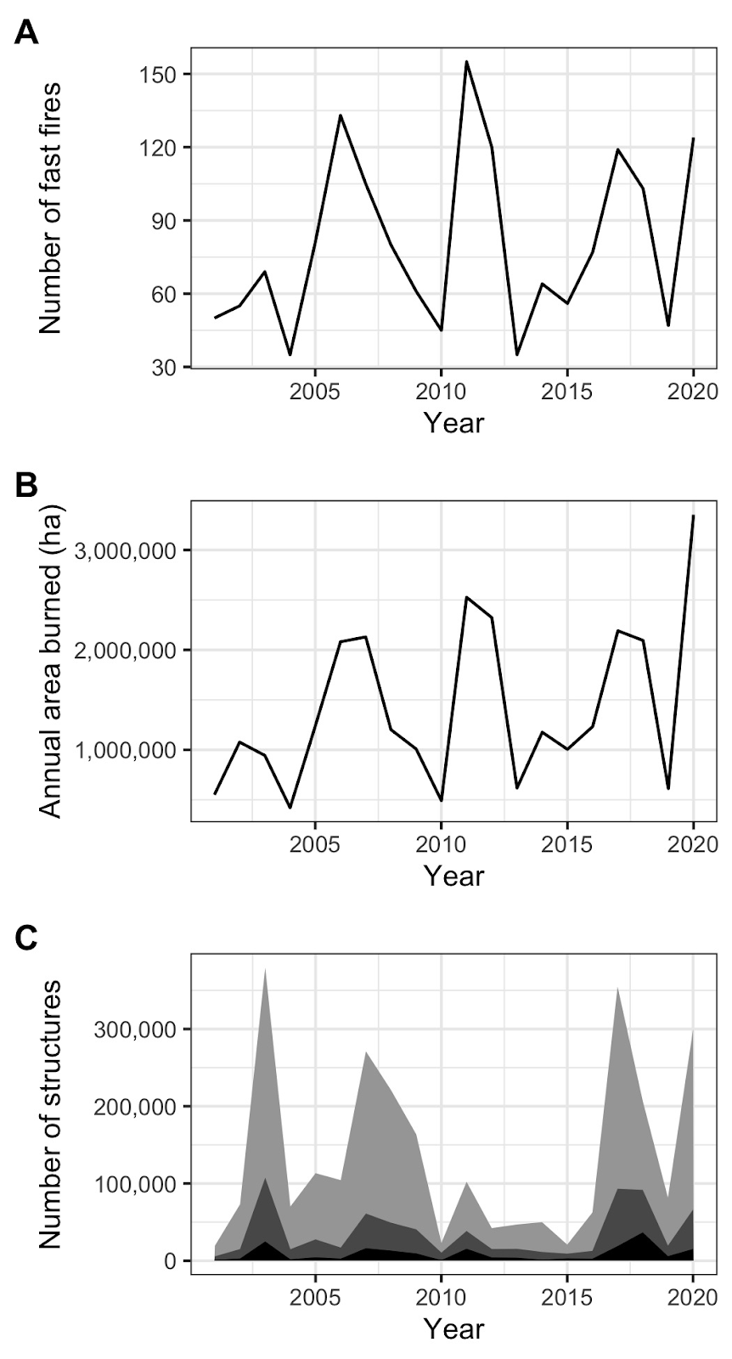

**Figure 4 : Exposure to fast fires (>1620 ha/day) in 2001-2020.** A) Cumulative number of fast fires. B) Cumulative area affected by fast fires. C) Trends in the cumulative number of structures within the perimeters of ***fast fires*** (black), within 1 km of the perimeters of fast fires (dark gray), and within 5 km  of the perimeters of fast fires (light gray). {GO WITH number of….

**Fast-growing fires are the most destructive and are getting faster across the West**

Fire speed matters. Fast-growing fires (those that burned >1620 ha/day) were associated with 75% of structures destroyed, and 60% of suppression expenditures. Further, fires are getting faster in nearly half of the conterminous U.S.; ecoregions that showed an increase in maximum daily growth constitute 48% of the land area (Figure SX). Across the 11 western states, there was a 27% increase in the rate of fire growth over just two decades. These increases in speed have occurred predominantly in the western U.S., and should come as no surprise when the increase in burned area since the mid-1980s has increased by ~300% (ref/s). As we demonstrate there is a very strong relationship between burned area and growth rate (Supplemental Figure X). In addition to these increases there was a tenfold increase in the number of residential structures threatened by fast growing fires from 2001-2020. In order to predict when and where events will have extreme socioeconomic impacts [(Balch et al., 2020a)](https://www.zotero.org/google-docs/?oOmHfu), growth rate may be an even more important metric to consider than size or severity. While there has been significant focus on mega-fires, often defined based on their size (refs), there has been a lack of attention on speed across fire events. New remote sensing-derived information on growth rate  (ref) offers an important proxy to understand fire speed across events and how it may be changing through time. The temporal nature of fire events is critical to understand, as the fastest fires are also often the most destructive and deadly.

**Table 1. Top 20 fastest growing fires across CONUS (2000-2020).** Summary of statistics from the top 20 fastest fires from FIRED linked to their associated incident command report (St. Denis et al., 2023). The top 20 fastest fires accrued an estimated $398M in suppression costs alone, exposed X properties (within 4 km) and destroyed over 9k structures. Many of the fastest fires burned in grasslands, although some burned in shrubland, chaparral, and forested areas. **… (Max Cook)**

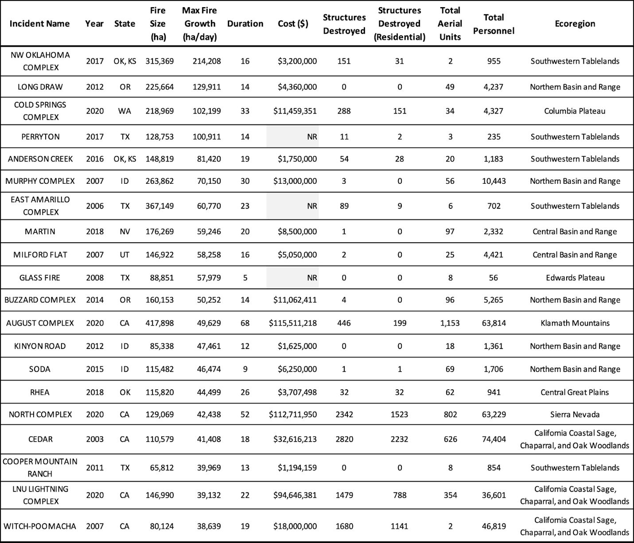

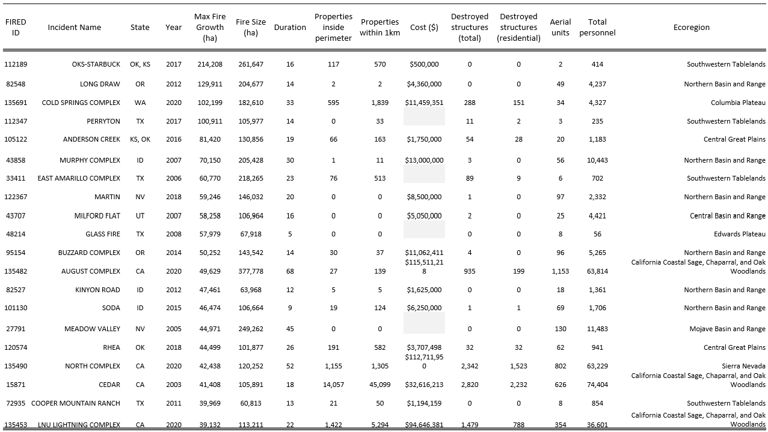

There are several reasons why fires may be getting faster.Climate-driven increases in large fire occurrence and burned area have been documented in the U.S. [(Abatzoglou and Williams, 2016; Dennison et al., 2014b; Iglesias et al., 2022)](https://www.zotero.org/google-docs/?2otpWb), but the explicit link between climate trends and changes in the speed of wildfire spread across the western US has not been rigorously evaluated. Juang et al. (2022) found that the rapid increase in western US forest-fire area since the mid-1980s was driven almost exclusively by rapidly increasing sizes of the largest forest fires. The proposed mechanism was straight-forward: larger fires have more potential for growth than smaller fires because fires with longer firelines have more potential for spread. It is also known that invasive grasses alone can drive increases in size and frequency [(Balch et al 2013; Fusco et al., 2019)](https://www.zotero.org/google-docs/?1BmrJc). Thus, as grass-fueled fires are some of the fastest, it may then follow that where vegetation transitions occur, e.g., from forest or shrubland to invasive grassland, fire speed will can increase. Instantaneous rate of spread is largely controlled by wind speed [(Cruz et al., 2022)](https://www.zotero.org/google-docs/?DWPoNj). Moreover, we know that there is a relationship between human ignitions and higher winds [(Abatzoglou et al., 2018; Hantson et al., 2022)](https://www.zotero.org/google-docs/?D3Df4z), as lightning generally does not occur under high wind conditions due to the constraints surrounding the types of storms that are associated with lightning [(Abatzoglou et al., 2018)](https://www.zotero.org/google-docs/?oYlJgm). There has been a steady increase (9%) in the percent of wildfires started by human ignitions since 1992 [(Cattau et al., 2020)](https://www.zotero.org/google-docs/?ljOIXD), and in 2017 90% of the wildfires were started by people [(Balch et al., 2018)](https://www.zotero.org/google-docs/?AM0AES). Given this, we expect that wildfires would in general be occurring during higher wind conditions by virtue of the fact that people start fires throughout the year and the probability of coinciding with windier conditions is higher [(Abatzoglou et al., 2018; Hantson et al., 2022)](https://www.zotero.org/google-docs/?TIkXpa).

The speed and timing of fire growth has a significant impact on emergency response, evacuation plans and community preparedness[(Cova et al., 2005)](https://www.zotero.org/google-docs/?IsmQYz). We estimate 753,621 structures were within 1 km of fast fire perimeters since 2000, prompting at least 925 emergency evacuation orders and over 1.5 million evacuated homes based on comparison with incident command reports [(St. Denis et al., 2020)](https://www.zotero.org/google-docs/?8li6MO). Moreover, fast fires account for 89% of residential structures destroyed in the U.S. (1999-2020). Wildfire-related emergency evacuation success is determined by increasing human settlements along with limited road access in fire-prone regions [(Cova et al., 2013; Dennison et al., 2007; Moritz et al., 2014)](https://www.zotero.org/google-docs/?DH7pTd) and efficient use of early warning systems and information delivery to impacted communities before and during evacuations (McLennan et al. 2019, Kuligowski 2021). We start nearly all the wildfires that threaten our homes [(Mietkiewicz et al., 2020)](https://www.zotero.org/google-docs/?tcFzIo), making understanding of the drivers of fire speed critically important. The proximity of ignitions to the WUI and the speed of fire growth may influence emergency management mobilization times and effective communication of evacuation orders ahead of the fire. This impact may be exacerbated in areas of rugged terrain or where dense development coincides with wildland fuels and limited road networks or telecommunication infrastructure (Moritz et al. 2014), although this is an important area of future research. With maximum daily growth occurring within the first five days for 83% of all events, this also emphasizes the need for preparedness and rapid response during extreme fire events [(Cova et al., 2021)](https://www.zotero.org/google-docs/?Tnd1NZ). This result reinforces the need for fire management teams to suppress potentially dangerous wildfires at the start when they threaten lives or property (Calkin et al. 2013).

Overall, the patterns and drivers of fire growth rate are important wildfire metrics to understand because fire speed can make wildfires dangerous and destructive. As a consequence, megafires should also be defined and considered based on their speed, not just their size. This work provides a critical advance in understanding national patterns and trends in fire growth rate, but more work is needed to understand fireline speed on a finer temporal resolution (e.g., hourly speed that greatly impacts fire containment decisions). The fastest growing fires are in grassland systems, highlighting the need to rethink grassland fire management strategies, especially as more and more homes are also being built into these landscapes. Widespread post-fire regeneration failures in forests that are documented throughout the west (Kim Davis 2019) will lead to much of that forest converting to grasslands, and annual grass invasion in non-forests is causing widespread conversion from shrublands to grasslands. We expect that these land cover changes combined with increasing aridity and extreme weather events due to climate change will lead to increased occurrence of fast fires, and faster fast fires in the future. The order of magnitude increase in settlement exposure helps to explain why we have seen the increase in the number of fire events that destroy more than 1000 homes in just the last five years. Fires are also getting faster across much of the west, and we expect that climate warming is contributing to this increase alongside changes in vegetation and anthropogenic ignition patterns. As the West has seen extremely devastating wildfires in just the past few years, such as the Camp wildfire in California, the Marshall wildfire in Colorado, or the Lahaina wildfire in Hawaii, it is critical to understand the pace of fire as we expect increasing losses in the future.

**CUTS from discussion:**

Beyond this allometric scaling phenomenon, we expect that speed may show a similar pattern to burned area relationships with temperature (and VPD, in particular Williams et al. 2019), given field-based studies that demonstrate a positive relationship between fire spread rate and VPD on fine-scales (Ray et al. 2005).

**Materials and Methods**

I.  Characterizing fire growth rates

We used the Fire Event Delineation Algorithm (FIRED) [(Balch et al., 2020b)](https://www.zotero.org/google-docs/?3OzJs5) to define fire events from which we obtained information on the daily progression of all fires in the US from the MODIS Collection 6 MCD64A1 Burned Area Product for 2001-2019. FIRED is a spatiotemporal flooding algorithm that inputs an area of interest, temporal extent, and spatial and temporal parameters, and uses these inputs to group gridded, monthly burned area detections into events. We used spatial temporal parameters of 5 463m pixels and 11 days based on an MTBS-based optimization [(Balch et al., 2020b)](https://www.zotero.org/google-docs/?44y1oq). FIRED outputs each event as a single fire perimeter as well as daily progression maps. In order to minimize the confounding effect of fires that were intentionally started, we excluded croplands. For each fire event, we calculated the simple fire spread rate (FSR) and the maximum single day growth (MG). FSR was calculated as the burned area for the entire event divided by the duration, and MG was the area burned on the day with the largest burned area.

Fire growth rate in CONUS is highly variable.  To identify areas of fast vs slow fire spread, we overlaid the FIRED data layers with Environmental Protection Agency level IV ecoregions [(Commission for Environmental Cooperation, 2006)](https://www.zotero.org/google-docs/?iSA7S0). These ecoregions reflect spatial differences in geology, landforms, soils, vegetation, climate, land use, wildlife, and hydrology [(Omernik and Griffith, 2014)](https://www.zotero.org/google-docs/?GYxKAC). For each ecoregion, we calculated the maximum single day growthMG, median MG,single day growth, and mean FGRmean FSR. It should be noted that fire suppression efforts to slow wildfires or change their movement with backburning, or other techniques, is likely integrated in the estimations and should be explored further.

It is important to note that daily growth rate is not equivalent to the spread rate of an actual fireline, although they are certainly related variables. Daily growth rate is integrated across a burned area pixel (~25 ha, or 250,000 m2) on an approximate daily basis based on the temporal resolution of the MODIS burned area product (MCD64A1). The MCD64A1 approximates the day of burning based on rapid changes in MODIS surface reflectance and is thus subject to uncertainties based on image quality, availability, and the output of the change detection algorithm (Giglio et al., 2018). Cutting-edge work is being done to integrate active fire satellite products to better characterize linear fireline spread on much finer spatial and temporal resolutions (refs) and to understand how to approximate linear growth from areal growth (DeCastro thesis citation).

II. Detecting temporal trends in fire growth rates and event duration

To identify temporal changes in fire dynamics, we produced time series of maximum single day growthMG, mean FSRFGR, and event duration at one-year timesteps for each level III ecoregion [(Commission for Environmental Cooperation, 2006)](https://www.zotero.org/google-docs/?t393ph). We choose to segment CONUS with level III ecoregions, which are coarser than level IV ecoregions, to ensure that most time series had sufficient data points to allow for meaningful trend detection.

The probabilistic distribution of fire growth rates has a very heavy left tail.  To obtain robust temporal trends, we excluded events shorter than five days and ecoregions with less than 10 data points. We then used the Theil-Sen estimator to fit linear models to the time series that satisfied these conditions.  By estimating the median of all slopes defined by all pairs of points in a two-dimensional space [(Sen, 1968)](https://www.zotero.org/google-docs/?MQidFa), this method provides an unbiased estimate of the regression slope [(Wang and Yu, 2005)](https://www.zotero.org/google-docs/?hWRrit).

III. Defining fast fires

Defining fast fires requires partitioning the continuum of fire speeds into two discrete classes, fast and non-fast. Given that ‘fast’ is a relative concept, the threshold between these classes is conditioned by the fundamental question of ‘fast with respect to what?’. Here, we focus on fires whose spread rates are higher than those that are not likely to have significant societal impact. To estimate this threshold, we constructed a dataset that combined growth rates from FIRED [(Balch et al., 2020b)](https://www.zotero.org/google-docs/?prdyln) and information on the number of structures damaged or destroyed per event obtained from incident command reports [(St. Denis et al., 2020)](https://www.zotero.org/google-docs/?iNvJFo) via spatiotemporal overlay.

Fire impacts depend not only on the physical properties of fire but also on the assets in harm’s way.  To account for the negligible potential of fires in remote areas to affect the built environment, we excluded from the dataset all fires that had not damaged or destroyed any structures. We then applied a regression tree (Breitman et al., 1998) to predict the number of structures damaged or destroyed as a function of maximum fire growth in a single day. The resulting tree was pruned to obtain two classes of fires, i.e., ‘very destructive’ and  ‘not very destructive’. Prior to fitting the model, the data were log-transformed to reduce the influence of anomalously large values on the classification.

The regression tree suggests that fires faster than 1620 ha/day damage or destroy a large number of structures. We choose this threshold as the minimum spread rate for a wildfire to be considered ‘fast’. For each EPA ecoregion level IV, we calculated the  total number of fast fires and the proportion of fast to total fires in 2000-2020.

IV. Assessing the exposure of the built environment to fast fires

To assess the exposure of the built environment to fast fires, we extracted records from the Historic Settlement Data Compilation of the U.S (HISDAC-US, REF) which is based on Zillow’s Transaction and Assessment Database (ZTRAX, REF(?)) within 1- and 4-km of fast fire perimeters from FIRED. The ZTRAX database offers a unique source of gridded property information at fine spatial (250 m) and temporal (semi-decade) resolutions. … We calculated the trends in exposure to fast fires across CONUS … Between 2000-2020, <trends in exposure> … While these data provide critical information on the location of structures within the built environment, some uncertainties exist, namely … (incompleteness in the data, uncertainty in the location of built structures, etc …) …

* zillow-FIRED overlay
* estimate trends in number of structures exposed to fast fires (within perimeter and within 1 and 4 km to fast fire) for CONUS
* Comment on uncertainty...

**Acknowledgements**

Acknowledgments follow the references and notes list but are not numbered. Start with text that acknowledges non-author contributions and then complete each of the sections below as separate paragraphs.

**Funding:** Provide complete funding information, including grant numbers, complete funding agency names, and recipient’s initials. Each funding source should be listed in a separate paragraph.

Examples:

National Institutes of Health grant U12AB123456 (PV, CHO)

National Institutes of Health grant R01AB123456 (PV, GS)

William K. Bowes Jr Foundation (PV)

German Research Foundation grant AB 1234/1-1

Office of Biological and Environmental Research of the U.S. Department of Energy Atmospheric System Research Program Interagency Agreement grant DE-SC0000001

National Institute of Health Research UK

UK-China Research and Innovation Partnership Fund through the Met Office Climate Science for Service Partnership (CSSP) China as part of the Newton Fund

**Author contributions:** Each author’s contribution(s) to the paper should be listed [we encourage you to follow the [CRediT](https://credit.niso.org/) model]. Each CRediT role should have its own line, and there should not be any punctuation in the initials.

Examples:

Conceptualization: SBB, DLA, MPW

Methodology: HP, FTGS, CW, JRK, NJB, PRB, JLS, EH

Investigation: SBB, DLA, MPW, WCB

Visualization: SFB, MJM, JLS, EH

Funding acquisition: SJE, MJM, JLS, EH

Project administration: JLS, EH

Supervision: SJE, MJM, JLS, EH

Writing – original draft: SBB, DLA, WCB, JLS, EH

Writing – review & editing: SBB, DLA, PRB, JLS, EH

**Competing interests:** Competing interests (including but not limited to patents, financial holdings, professional affiliations, advisory positions, and board memberships) of any of the authors must be listed. When authors have no competing interests, this should also be declared (e.g., “Authors declare that they have no competing interests.”).

**Data and materials availability:** All data, code, and materials used in the analysis must be available in some form to any researcher for purposes of reproducing or extending the analysis. Include a note explaining any restrictions on materials, such as materials transfer agreements (MTAs). Note accession numbers to any data relating to the paper and deposited in a public database; include a brief description of the data set or model with the number. If all data are in the paper and supplementary materials, include the sentence “All data are available in the main text or the supplementary materials.”

**References and Notes: (59/out of “about 50 main text refs”)**

[Abatzoglou, J.T., Balch, J.K., Bradley, B.A., Kolden, C.A., Abatzoglou, J.T., Balch, J.K., Bradley, B.A., Kolden, C.A., 2018. Human-related ignitions concurrent with high winds promote large wildfires across the USA. Int. J. Wildland Fire 27, 377–386. https://doi.org/10.1071/WF17149](https://www.zotero.org/google-docs/?eD5qVl)

[Abatzoglou, J.T., Williams, A.P., 2016. Impact of anthropogenic climate change on wildfire across western US forests. Proc. Natl. Acad. Sci. 113, 11770–11775. https://doi.org/10.1073/pnas.1607171113](https://www.zotero.org/google-docs/?eD5qVl)

[Andrews, P.L., 1986. BEHAVE: fire behavior prediction and fuel modeling system. USDA For. Serv. Gen. Tech. Rep. INT 194.](https://www.zotero.org/google-docs/?eD5qVl)

[Balch, J., Schoennagel, T., Williams, A., Abatzoglou, J., Cattau, M., Mietkiewicz, N., St. Denis, L., 2018. Switching on the Big Burn of 2017. Fire 1, 17. https://doi.org/10.3390/fire1010017](https://www.zotero.org/google-docs/?eD5qVl)

[Balch, J.K., Bradley, B.A., Abatzoglou, J.T., Nagy, R.C., Fusco, E.J., Mahood, A.L., 2017. Human-started wildfires expand the fire niche across the United States. Proc. Natl. Acad. Sci. 114, 2946–2951. https://doi.org/10.1073/pnas.1617394114](https://www.zotero.org/google-docs/?eD5qVl)

[Balch, J.K., Bradley, B.A., D’Antonio, C.M., Gómez-Dans, J., 2013. Introduced annual grass increases regional fire activity across the arid western USA (1980-2009). Glob. Change Biol. 19, 173–183. https://doi.org/10.1111/gcb.12046](https://www.zotero.org/google-docs/?eD5qVl)

[Balch, J.K., Iglesias, V., Braswell, A.E., Rossi, M.W., Joseph, M.B., Mahood, A.L., Shrum, T.R., White, C.T., Scholl, V.M., McGuire, B., Karban, C., Buckland, M., Travis, W.R., 2020a. Social‐Environmental Extremes: Rethinking Extraordinary Events as Outcomes of Interacting Biophysical and Social Systems. Earths Future 8. https://doi.org/10.1029/2019EF001319](https://www.zotero.org/google-docs/?eD5qVl)

[Balch, J.K., St. Denis, L.A., Mahood, A.L., Mietkiewicz, N.P., Williams, T.M., McGlinchy, J., Cook, M.C., 2020b. FIRED (Fire Events Delineation): An Open, Flexible Algorithm and Database of US Fire Events Derived from the MODIS Burned Area Product (2001–2019). Remote Sens. 12, 3498. https://doi.org/10.3390/rs12213498](https://www.zotero.org/google-docs/?eD5qVl)

[Bar-Massada, A., Stewart, S.I., Hammer, R.B., Mockrin, M.H., Radeloff, V.C., 2013. Using structure locations as a basis for mapping the wildland urban interface. J. Environ. Manage. 128, 540–547. https://doi.org/10.1016/j.jenvman.2013.06.021](https://www.zotero.org/google-docs/?eD5qVl)

[Cattau, M.E., Wessman, C., Mahood, A., Balch, J.K., 2020. Anthropogenic and lightning‐started fires are becoming larger and more frequent over a longer season length in the U.S.A. Glob. Ecol. Biogeogr. 29, 668–681. https://doi.org/10.1111/geb.13058](https://www.zotero.org/google-docs/?eD5qVl)

[Coen, J.L., Stavros, E.N., Fites-Kaufman, J.A., 2018. Deconstructing the King megafire. Ecol. Appl. 28, 1565–1580. https://doi.org/10.1002/eap.1752](https://www.zotero.org/google-docs/?eD5qVl)

[Commission for Environmental Cooperation, 2006. Ecological regions of North America: toward a common perspective.](https://www.zotero.org/google-docs/?eD5qVl)

[Cook, M.C., 2021. Drivers of wildfire-related home loss across the western United States 2001-2018. University of Colorado.](https://www.zotero.org/google-docs/?eD5qVl)

[Cova, T.J., Dennison, P.E., Kim, T.H., Moritz, M.A., 2005. Setting Wildfire Evacuation Trigger Points Using Fire Spread Modeling and GIS. Trans. GIS 9, 603–617. https://doi.org/10.1111/j.1467-9671.2005.00237.x](https://www.zotero.org/google-docs/?eD5qVl)

[Cova, T.J., Li, D., Siebeneck, L.K., Drews, F.A., 2021. Toward Simulating Dire Wildfire Scenarios. Nat. Hazards Rev. 22, 06021003. https://doi.org/10.1061/(ASCE)NH.1527-6996.0000474](https://www.zotero.org/google-docs/?eD5qVl)

[Cova, T.J., Theobald, D.M., Norman, J.B., Siebeneck, L.K., 2013. Mapping wildfire evacuation vulnerability in the western US: the limits of infrastructure. GeoJournal 78, 273–285. https://doi.org/10.1007/s10708-011-9419-5](https://www.zotero.org/google-docs/?eD5qVl)

[Cruz, M.G., Alexander, M.E., Kilinc, M., 2022. Wildfire Rates of Spread in Grasslands under Critical Burning Conditions. Fire 5, 55. https://doi.org/10.3390/fire5020055](https://www.zotero.org/google-docs/?eD5qVl)

[Dennison, P.E., Brewer, S.C., Arnold, J.D., Moritz, M.A., 2014a. Large wildfire trends in the western United States. Geophys. Res. Lett. 41, 2928–2933. https://doi.org/10.1002/2014GL059576](https://www.zotero.org/google-docs/?eD5qVl)

[Dennison, P.E., Brewer, S.C., Arnold, J.D., Moritz, M.A., 2014b. Large wildfire trends in the western United States. Geophys. Res. Lett. 41, 2928–2933. https://doi.org/10.1002/2014GL059576](https://www.zotero.org/google-docs/?eD5qVl)

[Dennison, P.E., Cova, T.J., Mortiz, M.A., 2007. WUIVAC: a wildland-urban interface evacuation trigger model applied in strategic wildfire scenarios. Nat. Hazards 41, 181–199. https://doi.org/10.1007/s11069-006-9032-y](https://www.zotero.org/google-docs/?eD5qVl)

[Dillon, G.K., Menakis, J.P., fay, F., 2015. Wildland Fire Potential: A Tool for Assessing Wildfire Risk and Fuels Management Needs. USDA For. Serv. Proc. RMRS-P-73 17.](https://www.zotero.org/google-docs/?eD5qVl)

[Dowdy, A.J., Ye, H., Pepler, A., Thatcher, M., Osbrough, S.L., Evans, J.P., Di Virgilio, G., McCarthy, N., 2019. Future changes in extreme weather and pyroconvection risk factors for Australian wildfires. Sci. Rep. 9, 10073. https://doi.org/10.1038/s41598-019-46362-x](https://www.zotero.org/google-docs/?eD5qVl)

[Falk, D.A., Heyerdahl, E.K., Brown, P.M., Farris, C., Fulé, P.Z., McKenzie, D., Swetnam, T.W., Taylor, A.H., Van Horne, M.L., 2011. Multi-scale controls of historical forest-fire regimes: new insights from fire-scar networks. Front. Ecol. Environ. 9, 446–454. https://doi.org/10.1890/100052](https://www.zotero.org/google-docs/?eD5qVl)

[Finney, M.A., McHugh, C.W., Grenfell, I.C., Riley, K.L., Short, K.C., 2011. A simulation of probabilistic wildfire risk components for the continental United States. Stoch. Environ. Res. Risk Assess. 25, 973–1000. https://doi.org/10.1007/s00477-011-0462-z](https://www.zotero.org/google-docs/?eD5qVl)

[Fusco, E.J., Finn, J.T., Balch, J.K., Nagy, R.C., Bradley, B.A., 2019. Invasive grasses increase fire occurrence and frequency across US ecoregions. Proc. Natl. Acad. Sci. 116, 23594–23599. https://doi.org/10.1073/pnas.1908253116](https://www.zotero.org/google-docs/?eD5qVl)

[Goss, M., Swain, D.L., Abatzoglou, J.T., Sarhadi, A., Kolden, C.A., Williams, A.P., Diffenbaugh, N.S., 2020. Climate change is increasing the likelihood of extreme autumn wildfire conditions across California. Environ. Res. Lett. 15, 094016. https://doi.org/10.1088/1748-9326/ab83a7](https://www.zotero.org/google-docs/?eD5qVl)

[Haas, J.R., Calkin, D.E., Thompson, M.P., 2013. A national approach for integrating wildfire simulation modeling into Wildland Urban Interface risk assessments within the United States. Landsc. Urban Plan. 119, 44–53. https://doi.org/10.1016/j.landurbplan.2013.06.011](https://www.zotero.org/google-docs/?eD5qVl)

[Haight, R.G., Cleland, D.T., Hammer, R.B., Radeloff, V.C., Rupp, T.S., 2004. Assessing Fire Risk in the Wildland-Urban Interface. J. For. October/November, 41–48.](https://www.zotero.org/google-docs/?eD5qVl)

[Hantson, S., Andela, N., Goulden, M.L., Randerson, J.T., 2022. Human-ignited fires result in more extreme fire behavior and ecosystem impacts. Nat. Commun. 13, 2717. https://doi.org/10.1038/s41467-022-30030-2](https://www.zotero.org/google-docs/?eD5qVl)

[Higuera, P.E., Shuman, B.N., Wolf, K.D., 2021. Rocky Mountain subalpine forests now burning more than any time in recent millennia. Proc. Natl. Acad. Sci. 118, e2103135118. https://doi.org/10.1073/pnas.2103135118](https://www.zotero.org/google-docs/?eD5qVl)

[Iglesias, V., Balch, J.K., Travis, W.R., 2022. U.S. fires became larger, more frequent, and more widespread in the 2000s. Sci. Adv. 8, eabc0020. https://doi.org/10.1126/sciadv.abc0020](https://www.zotero.org/google-docs/?eD5qVl)

[Johnston, F.H., Borchers-Arriagada, N., Morgan, G.G., Jalaludin, B., Palmer, A.J., Williamson, G.J., Bowman, D.M.J.S., 2021. Unprecedented health costs of smoke-related PM2.5 from the 2019–20 Australian megafires. Nat. Sustain. 4, 42–47. https://doi.org/10.1038/s41893-020-00610-5](https://www.zotero.org/google-docs/?eD5qVl)

[Joseph, M.B., Rossi, M.W., Mietkiewicz, N.P., Mahood, A.L., Cattau, M.E., St. Denis, L.A., Nagy, R.C., Iglesias, V., Abatzoglou, J.T., Balch, J.K., 2019. Spatiotemporal prediction of wildfire size extremes with Bayesian finite sample maxima. Ecol. Appl. 29. https://doi.org/10.1002/eap.1898](https://www.zotero.org/google-docs/?eD5qVl)

[Kramer, H.A., Butsic, V., Mockrin, M.H., Ramirez-Reyes, C., Alexandre, P.M., Radeloff, V.C., 2021. Post-wildfire rebuilding and new development in California indicates minimal adaptation to fire risk. Land Use Policy 107, 105502. https://doi.org/10.1016/j.landusepol.2021.105502](https://www.zotero.org/google-docs/?eD5qVl)

[Leyk, S., Uhl, J.H., 2018. HISDAC-US, historical settlement data compilation for the conterminous United States over 200 years. Sci. Data 5, 180175. https://doi.org/10.1038/sdata.2018.175](https://www.zotero.org/google-docs/?eD5qVl)

[Leyk, S., Uhl, J.H., Connor, D.S., Braswell, A.E., Mietkiewicz, N., Balch, J.K., Gutmann, M., 2020a. Two centuries of settlement and urban development in the United States. Sci. Adv. 6, eaba2937. https://doi.org/10.1126/sciadv.aba2937](https://www.zotero.org/google-docs/?eD5qVl)

[Leyk, S., Uhl, J.H., Connor, D.S., Braswell, A.E., Mietkiewicz, N., Balch, J.K., Gutmann, M., 2020b. Two centuries of settlement and urban development in the United States. Sci. Adv. 6, eaba2937. https://doi.org/10.1126/sciadv.aba2937](https://www.zotero.org/google-docs/?eD5qVl)

[Maranghides, A., Link, E., Mell, W. “Ruddy,” Hawks, S., Wilson, M., Brewer, W., Brown, C., Vihnaneck, B., Walton, W.D., 2021. A Case Study of the Camp Fire – Fire Progression Timeline (No. NIST TN 2135). National Institute of Standards and Technology, Gaithersburg, MD. https://doi.org/10.6028/NIST.TN.2135](https://www.zotero.org/google-docs/?eD5qVl)

[Mietkiewicz, N., Balch, J.K., Schoennagel, T., Leyk, S., St. Denis, L.A., Bradley, B.A., 2020. In the Line of Fire: Consequences of Human-Ignited Wildfires to Homes in the U.S. (1992–2015). Fire 3, 50. https://doi.org/10.3390/fire3030050](https://www.zotero.org/google-docs/?eD5qVl)

[Moritz, M.A., Batllori, E., Bradstock, R.A., Gill, A.M., Handmer, J., Hessburg, P.F., Leonard, J., McCaffrey, S., Odion, D.C., Schoennagel, T., Syphard, A.D., 2014. Learning to coexist with wildfire. Nature 515, 58–66. https://doi.org/10.1038/nature13946](https://www.zotero.org/google-docs/?eD5qVl)

[Nagy, R.C., Fusco, E., Bradley, B., Abatzoglou, J.T., Balch, J., 2018. Human-Related Ignitions Increase the Number of Large Wildfires across U.S. Ecoregions. Fire 1, 4. https://doi.org/10.3390/fire1010004](https://www.zotero.org/google-docs/?eD5qVl)

[Omernik, J.M., Griffith, G.E., 2014. Ecoregions of the Conterminous United States: Evolution of a Hierarchical Spatial Framework. Environ. Manage. 54, 1249–1266. https://doi.org/10.1007/s00267-014-0364-1](https://www.zotero.org/google-docs/?eD5qVl)

[Parks, S.A., Abatzoglou, J.T., 2020. Warmer and Drier Fire Seasons Contribute to Increases in Area Burned at High Severity in Western US Forests From 1985 to 2017. Geophys. Res. Lett. 47. https://doi.org/10.1029/2020GL089858](https://www.zotero.org/google-docs/?eD5qVl)

[Perry, G.L.W., 1998. Current approaches to modelling the spread of wildland ®re: a review. Prog. Phys. Geogr. 22, 222–245.](https://www.zotero.org/google-docs/?eD5qVl)

[Picotte, J.J., Peterson, B., Meier, G., Howard, S.M., 2016. 1984–2010 trends in fire burn severity and area for the conterminous US. Int. J. Wildland Fire 25, 413. https://doi.org/10.1071/WF15039](https://www.zotero.org/google-docs/?eD5qVl)

[Radeloff, V.C., Helmers, D.P., Kramer, H.A., Mockrin, M.H., Alexandre, P.M., Bar-Massada, A., Butsic, V., Hawbaker, T.J., Martinuzzi, S., Syphard, A.D., Stewart, S.I., 2018. Rapid growth of the US wildland-urban interface raises wildfire risk. Proc. Natl. Acad. Sci. 115, 3314–3319. https://doi.org/10.1073/pnas.1718850115](https://www.zotero.org/google-docs/?eD5qVl)

[Rao, K., Williams, A.P., Diffenbaugh, N.S., Yebra, M., Konings, A.G., 2022. Plant-water sensitivity regulates wildfire vulnerability. Nat. Ecol. Evol. https://doi.org/10.1038/s41559-021-01654-2](https://www.zotero.org/google-docs/?eD5qVl)

[Roos, C.I., Swetnam, T.W., Ferguson, T.J., Liebmann, M.J., Loehman, R.A., Welch, J.R., Margolis, E.Q., Guiterman, C.H., Hockaday, W.C., Aiuvalasit, M.J., Battillo, J., Farella, J., Kiahtipes, C.A., 2021. Native American fire management at an ancient wildland–urban interface in the Southwest United States. Proc. Natl. Acad. Sci. 118, e2018733118. https://doi.org/10.1073/pnas.2018733118](https://www.zotero.org/google-docs/?eD5qVl)

[Roos, C.I., Zedeño, M.N., Hollenback, K.L., Erlick, M.M.H., 2018. Indigenous impacts on North American Great Plains fire regimes of the past millennium. Proc. Natl. Acad. Sci. 115, 8143–8148. https://doi.org/10.1073/pnas.1805259115](https://www.zotero.org/google-docs/?eD5qVl)

[Rothermel, R.C., 1972. A mathematical model for predicting fire spread in wildland fuels. Intermountain Forest & Range Experiment Station, Forest Service, US ….](https://www.zotero.org/google-docs/?eD5qVl)

[Sen, P.K., 1968. Estimates of the Regression Coefficient Based on Kendall’s Tau. J. Am. Stat. Assoc. 63, 1379–1389.](https://www.zotero.org/google-docs/?eD5qVl)

[St. Denis, L.A., Mietkiewicz, N.P., Short, K.C., Buckland, M., Balch, J.K., 2020. All-hazards dataset mined from the US National Incident Management System 1999–2014. Sci. Data 7, 64. https://doi.org/10.1038/s41597-020-0403-0](https://www.zotero.org/google-docs/?eD5qVl)

[Stavros, E.N., Abatzoglou, J.T., McKenzie, D., Larkin, N.K., 2014. Regional projections of the likelihood of very large wildland fires under a changing climate in the contiguous Western United States. Clim. Change 126, 455–468. https://doi.org/10.1007/s10584-014-1229-6](https://www.zotero.org/google-docs/?eD5qVl)

[Stephens, S.L., Burrows, N., Buyantuyev, A., Gray, R.W., Keane, R.E., Kubian, R., Liu, S., Seijo, F., Shu, L., Tolhurst, K.G., van Wagtendonk, J.W., 2014. Temperate and boreal forest mega-fires: characteristics and challenges. Front. Ecol. Environ. 12, 115–122. https://doi.org/10.1890/120332](https://www.zotero.org/google-docs/?eD5qVl)

[Sugihara, N.G., Van Wagtendonk, J.W., Fites-Kaufman, J., Shaffer, K.E., Thode, A.E., 2006. Fire in California’s ecosystems. University of California Press.](https://www.zotero.org/google-docs/?eD5qVl)

[Sullivan, A.L., 2009a. Wildland surface fire spread modelling, 1990 - 2007. 1: Physical and quasi-physical models. Int. J. Wildland Fire 18, 349. https://doi.org/10.1071/WF06143](https://www.zotero.org/google-docs/?eD5qVl)

[Sullivan, A.L., 2009b. Wildland surface fire spread modelling, 1990 - 2007. 2: Empirical and quasi-empirical models. Int. J. Wildland Fire 18, 369. https://doi.org/10.1071/WF06142](https://www.zotero.org/google-docs/?eD5qVl)

[Uhl, J.H., Leyk, S., McShane, C.M., Braswell, A.E., Connor, D.S., Balk, D., 2021. Fine-grained, spatiotemporal datasets measuring 200 years of land development in the United States. Earth Syst. Sci. Data 13, 119–153. https://doi.org/10.5194/essd-13-119-2021](https://www.zotero.org/google-docs/?eD5qVl)

[Wang, X., Swystun, T., Oliver, J., Flannigan, M.D., 2021. One extreme fire weather event determines the extent and frequency of wildland fires. Environ. Res. Lett. 16, 114031. https://doi.org/10.1088/1748-9326/ac2f64](https://www.zotero.org/google-docs/?eD5qVl)

[Wang, X., Yu, Q., 2005. Unbiasedness of the Theil–Sen estimator. J. Nonparametric Stat. 17, 685–695. https://doi.org/10.1080/10485250500039452](https://www.zotero.org/google-docs/?eD5qVl)

**TABLES**

Westwide summaries:

<https://docs.google.com/spreadsheets/d/1aIU_iH3niQHSz8Fs3Wkc_-Tujz54QlFa6K1-oehv0Ms/edit#gid=0>

|  |  |  |  |  |  |
| --- | --- | --- | --- | --- | --- |
| Area | Ecoregion mean | Ecoregion median | Bootstrapped mean | Bootstrapped median | Modeled |
| California | 4.24 +/-0.38 | 2.39+/-0.28 | 4.3+/-0.4 | 2.25+/-0.31 | 4.28 |
| West | 2.14 +/- 0.12 | 0 +/- 0.75 | 1.0+/-0.26 | 0+/-0.88 |  |

Notes from Virginia on westwide/CA summary:

I calculated temporal changes in fire growth rates for California and for the west. For California, I did (a) mean and median of  Theil-Sen regression coefficients of all ecoregions in the state; (b) bootstrapped estimation of the Theil-Sen coefficient for the state, and (c) Theil-Sen coefficient for the state. For the west, I only did (a) and (b) because, as we’ve discussed, (c) it takes forever.

Here are the values in ha/day/year: <https://docs.google.com/spreadsheets/d/1aIU_iH3niQHSz8Fs3Wkc_-Tujz54QlFa6K1-oehv0Ms/edit?usp=sharing>

Ecoregion Level 1 summaries:

<https://docs.google.com/spreadsheets/d/1KZ1WNwOBnQNlIx3-D-hb_QURGJc2typYzKwe81F3-TU/edit#gid=2134256498>

Trend coefficients:

<https://docs.google.com/spreadsheets/d/1WBDStHwRYouqaSGyV8fDVuvjjUGXLm563k1DRGFcsPM/edit#gid=2014372530>

Area burned on max daily growth day:

<https://docs.google.com/spreadsheets/d/1tOsoVVqjI-0_Dqu3zdNBt0caOBnu9TbDA9IHYwxZSkI/edit#gid=286868974>

(SUPPLEMENTAL) Top 100 fastest fires in CONUS:

<https://docs.google.com/spreadsheets/d/1POIYIgwnZiCb01SS8N7QBZH6IyOQkxbuu9BoTrUj4DY/edit?usp=sharing>

[Discuss Rim fire example and connection to societal costs.]

[**Suppl? Table 1. Percent of area burned during the day of maximum fire growth, 2001-2018, for landcover types within ecoregions**](https://docs.google.com/spreadsheets/d/1tOsoVVqjI-0_Dqu3zdNBt0caOBnu9TbDA9IHYwxZSkI/edit?usp=sharing)

(OLD) Table(s) 1. Group by level 1?

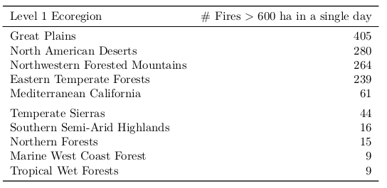

**(OLD) Table 2.** Summary statistics for fire spread rate by land cover class within level 1 ecoregions.

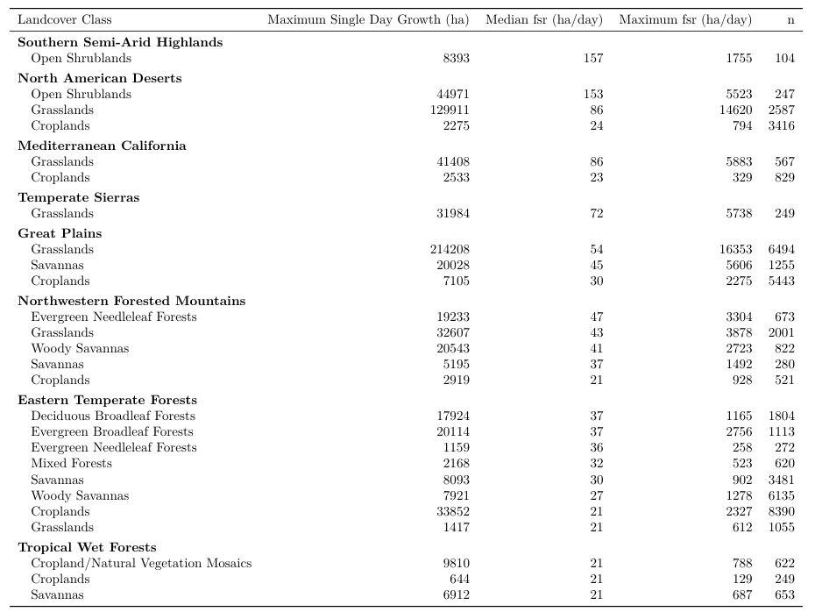

**(OLD) Table 3.** Percent of area burned during the day of maximum fire growth, 2001-2018, for land cover types within ecoregions with 100 or more fire events.

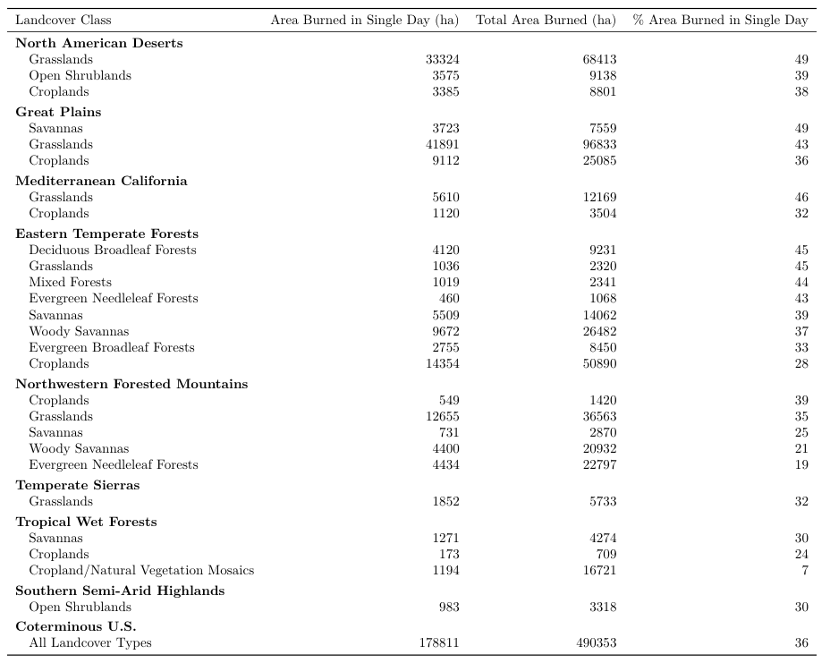

**SUPPLEMENTAL**

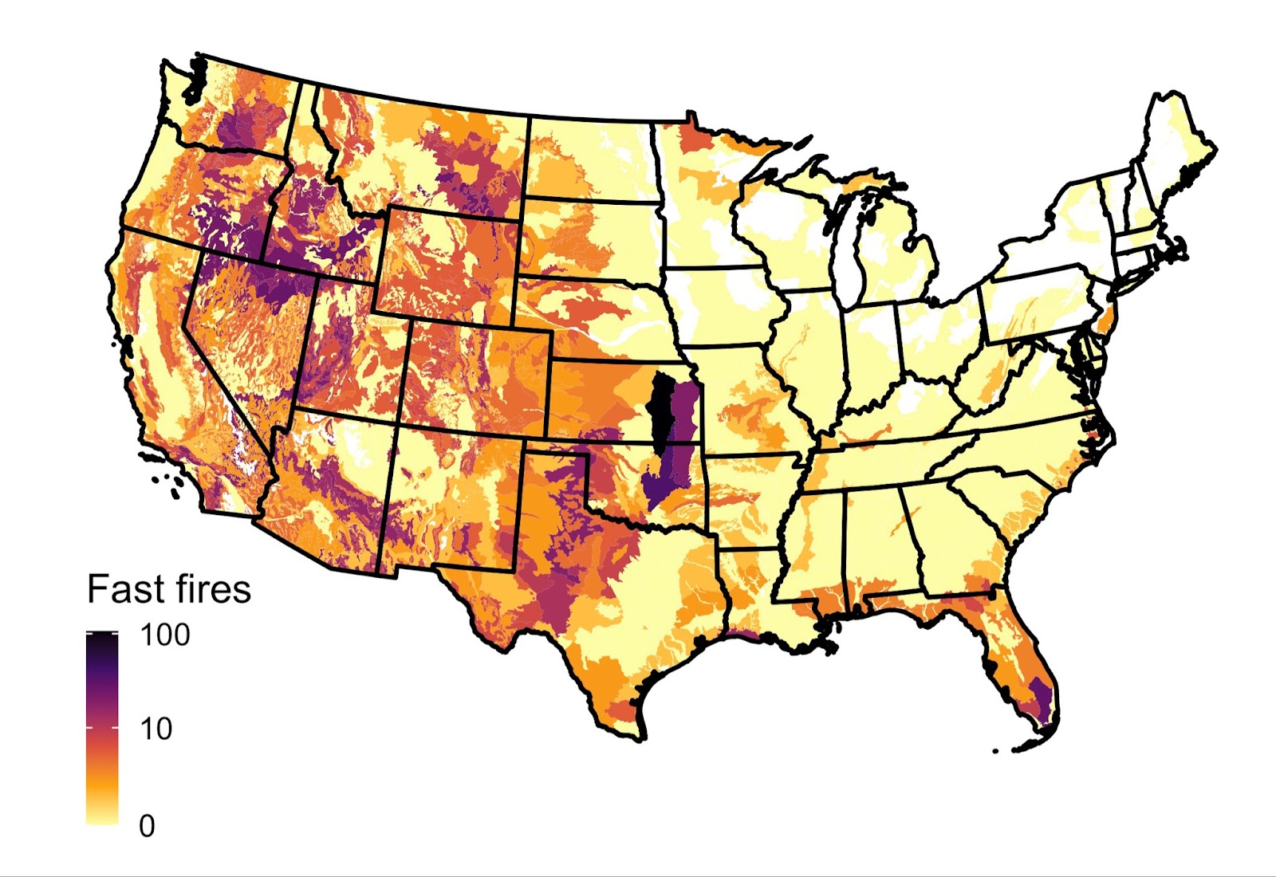

**Figure 3.** Number of fast fires (>=1620ha/day) per EPA ecoregion level IV (2001-2020). Ecoregions that were not affected by fires in 2000-2020 are shown in white.

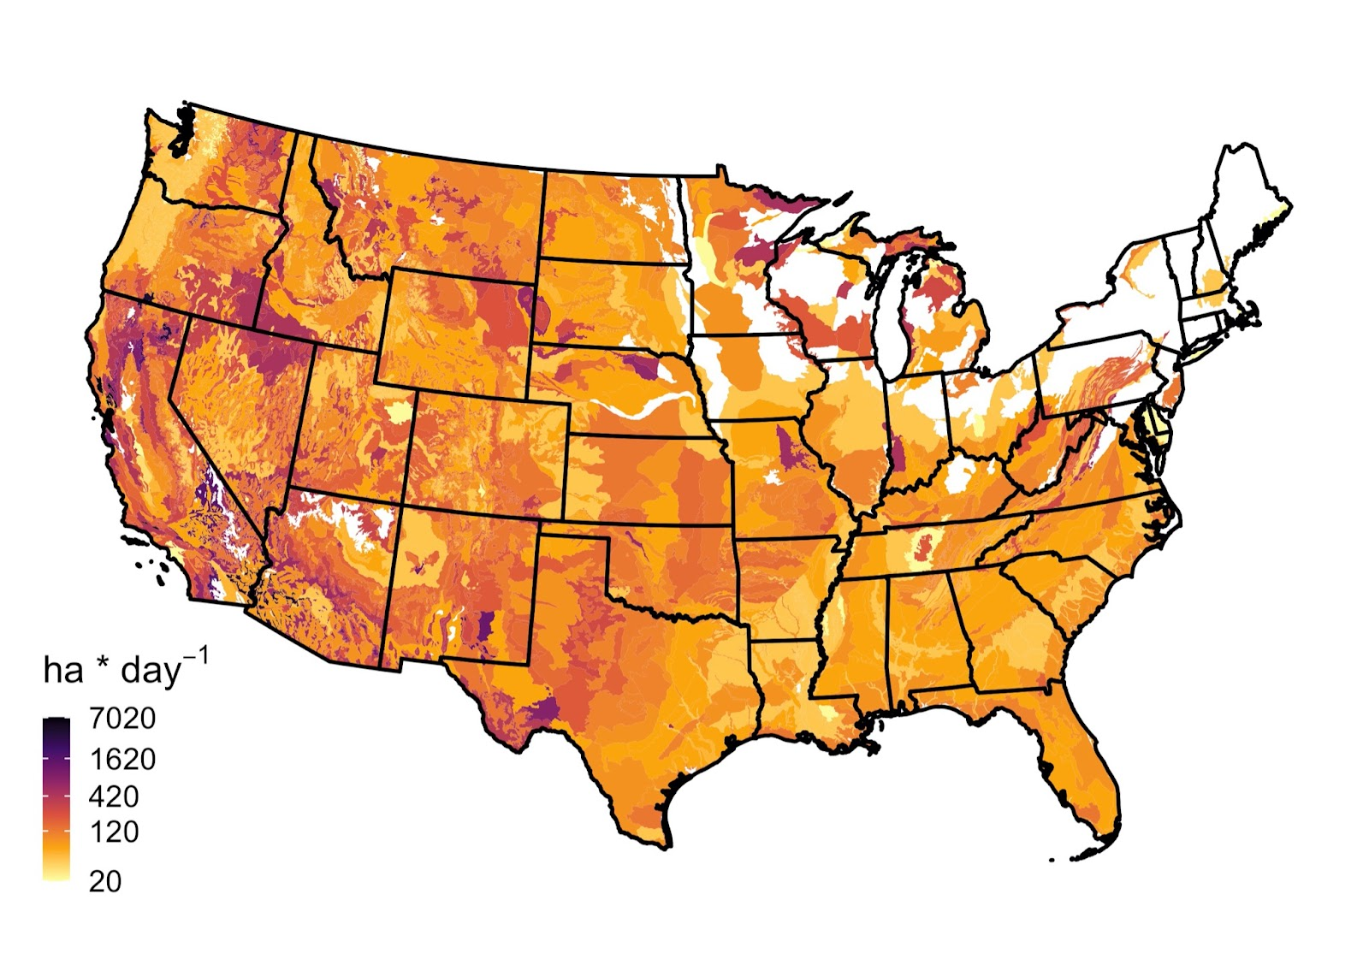

**Figure S0.** Median maximum single-day growth per EPA ecoregion level IV (2000-2020). Ecoregions that were not affected by fires in 2000-2020 are shown in white.

**Figure 4 : Exposure to fast fires (>1620 ha/day) in 2001-2020.** A) Cumulative number of fast fires. B) Cumulative area affected by fast fires. C) Trends in the cumulative number of structures within the perimeters of ***fast fires*** (black), within 1 km of the perimeters of fast fires (dark gray), and within 5 km  of the perimeters of fast fires (light gray). {GO WITH number of….

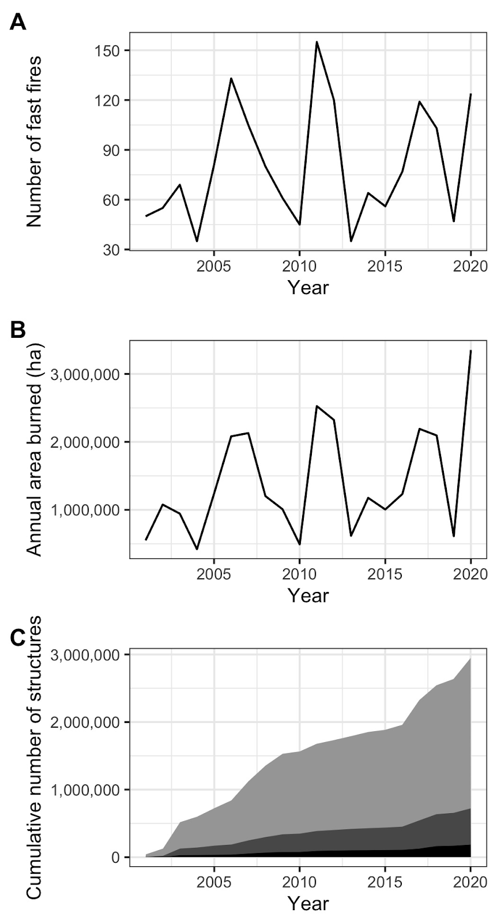

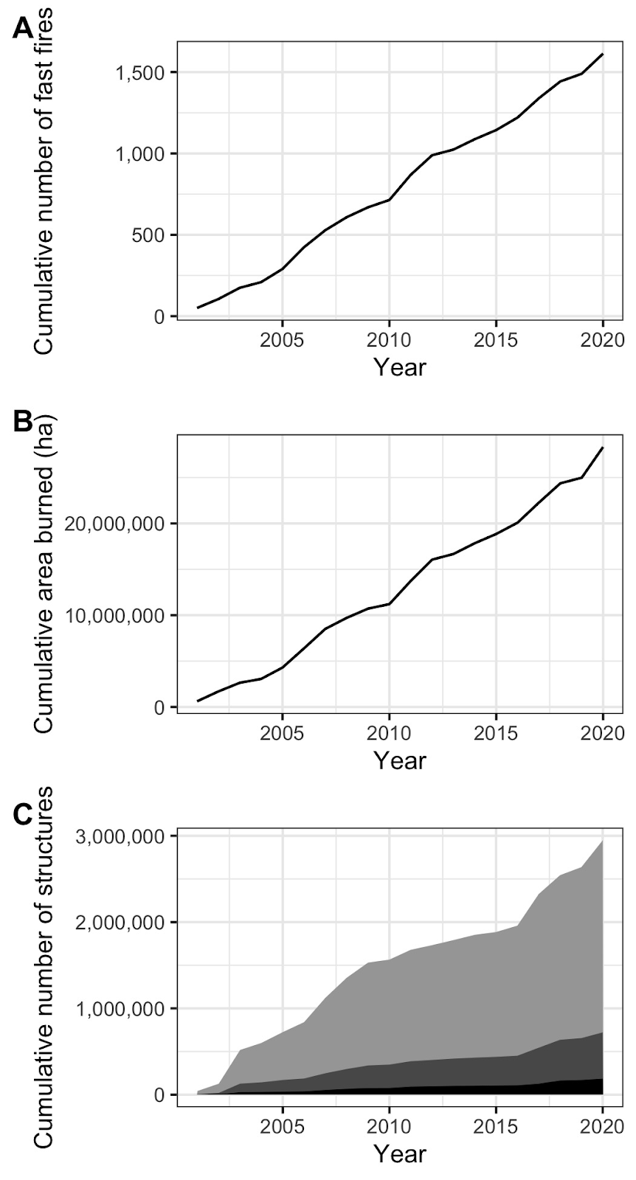

**Figure 4 : Exposure to fast fires (>1620 ha/day) in 2001-2020.** A) Cumulative number of fast fires. B) Cumulative area affected by fast fires. C) Trends in the cumulative number of structures within the perimeters of ***fast fires*** (black), within 1 km of the perimeters of fast fires (dark gray), and within 5 km  of the perimeters of fast fires (light gray). {GO WITH number of….

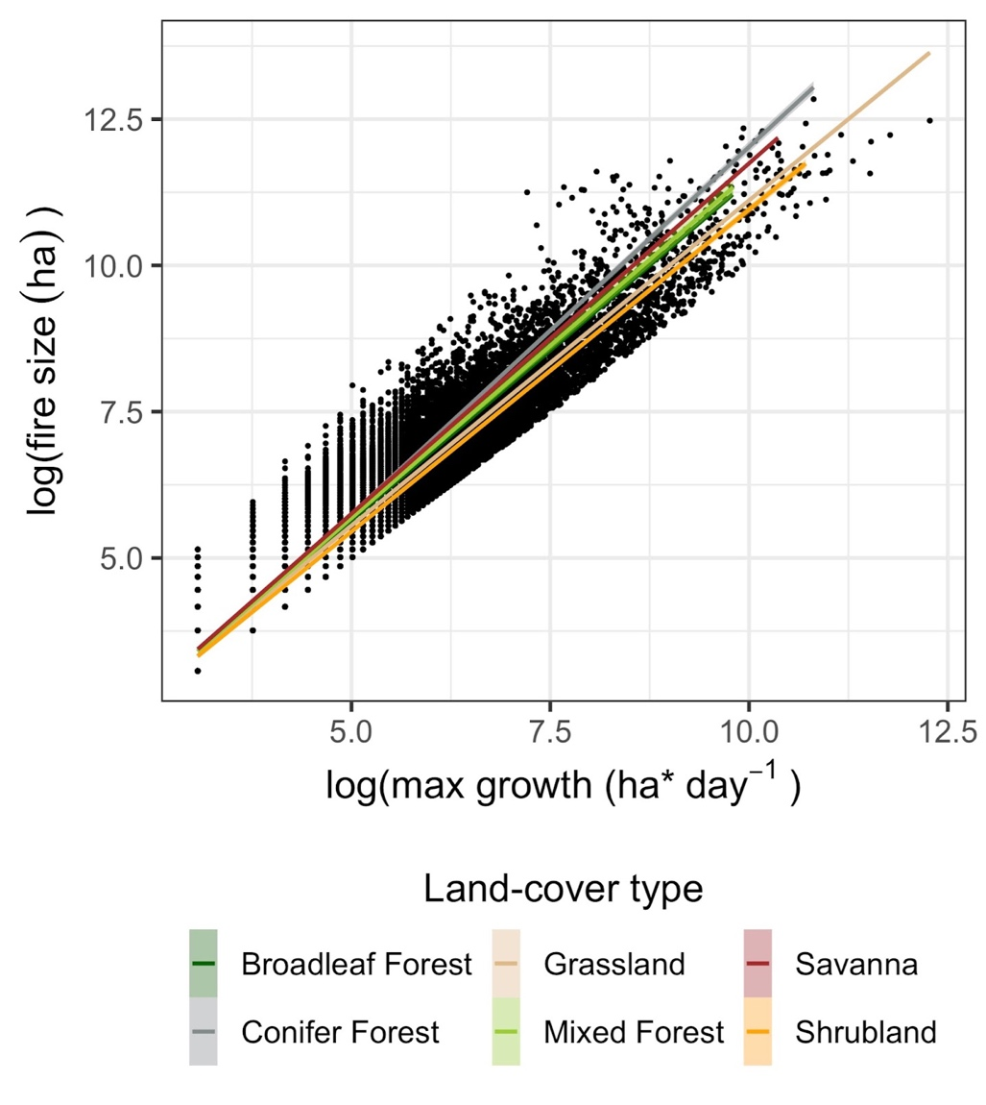

**Figure S1: Relationship between maximum daily fire growth rate and final fire size in each landcover class** in 2000-2020. The log-log transformed variables are strongly correlated suggesting that they follow a power law (broadleaf forest: coeff = 1.16, adjusted R2 = 0.9; conifer forest: coeff = 1.26, adjusted R2 = 0.919; grassland: coeff = 1.11, adjusted R2 = 0.924; mixed forest: coeff = 1.18, adjusted R2 = 0.878; savana: coeff = 1.2, adjusted R2 = 0.882; shrubland: coeff = 1.1, adjusted R2 = 0.96).

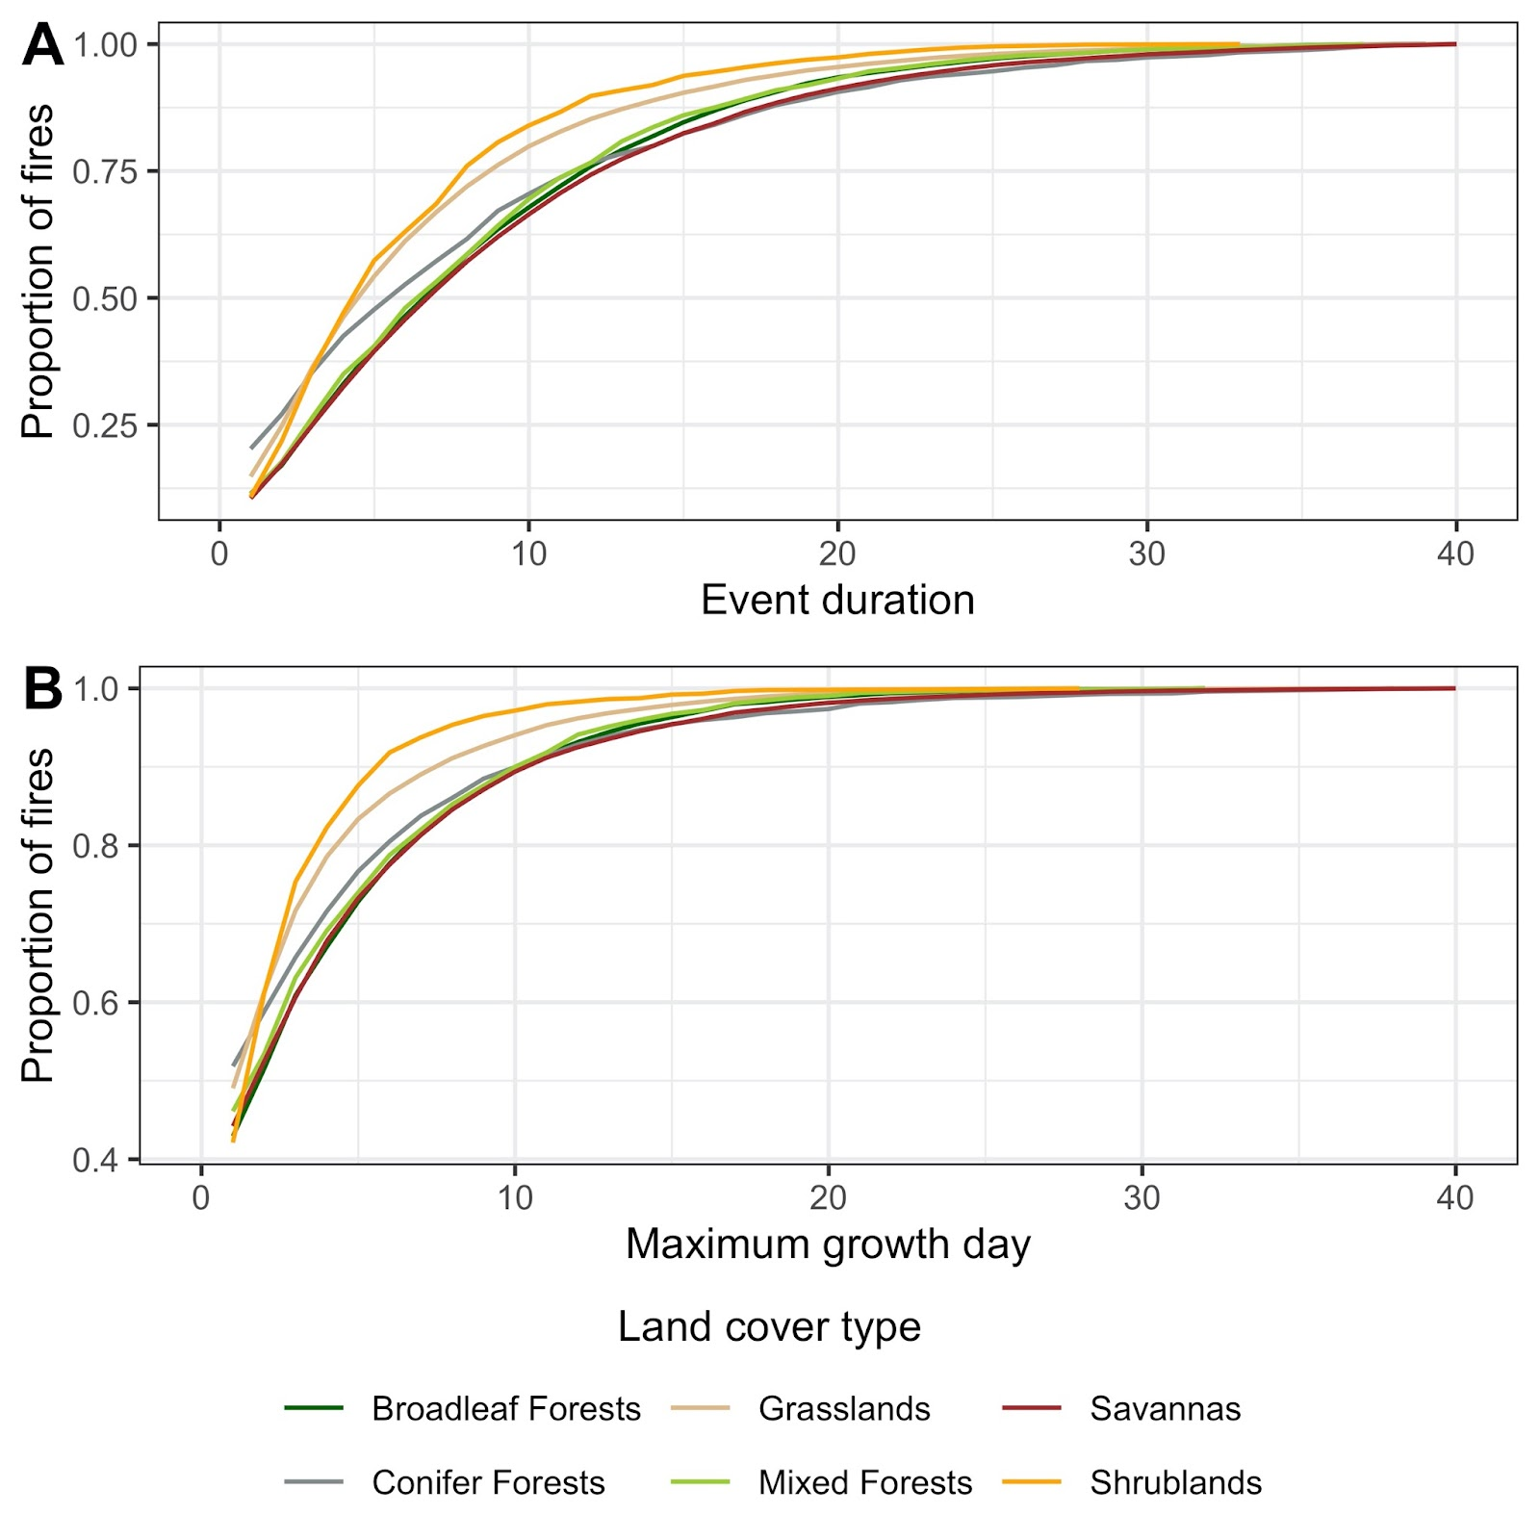

**Figure S2: Empirical cumulative distribution of (A) fire duration and (B) max growth day.**

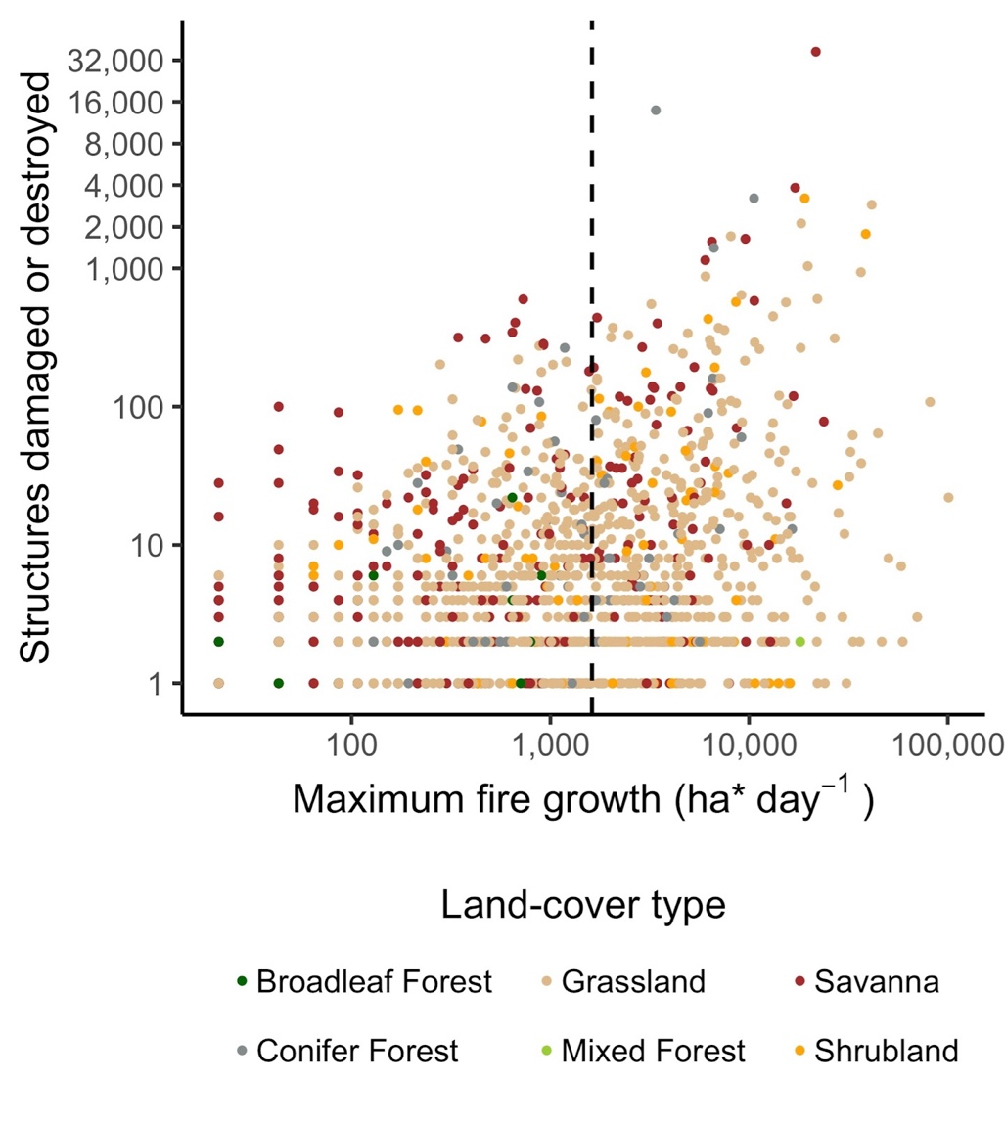

**Fig. S3. Defining fast fires as a function of social-economic impacts.** Log-transformed number of structures destroyed as a function of log-transformed fire growth. The dashed lines show the minimum growth of ‘fast fires’ (1620 ha/day). Note that the x and y axis are in log scale.

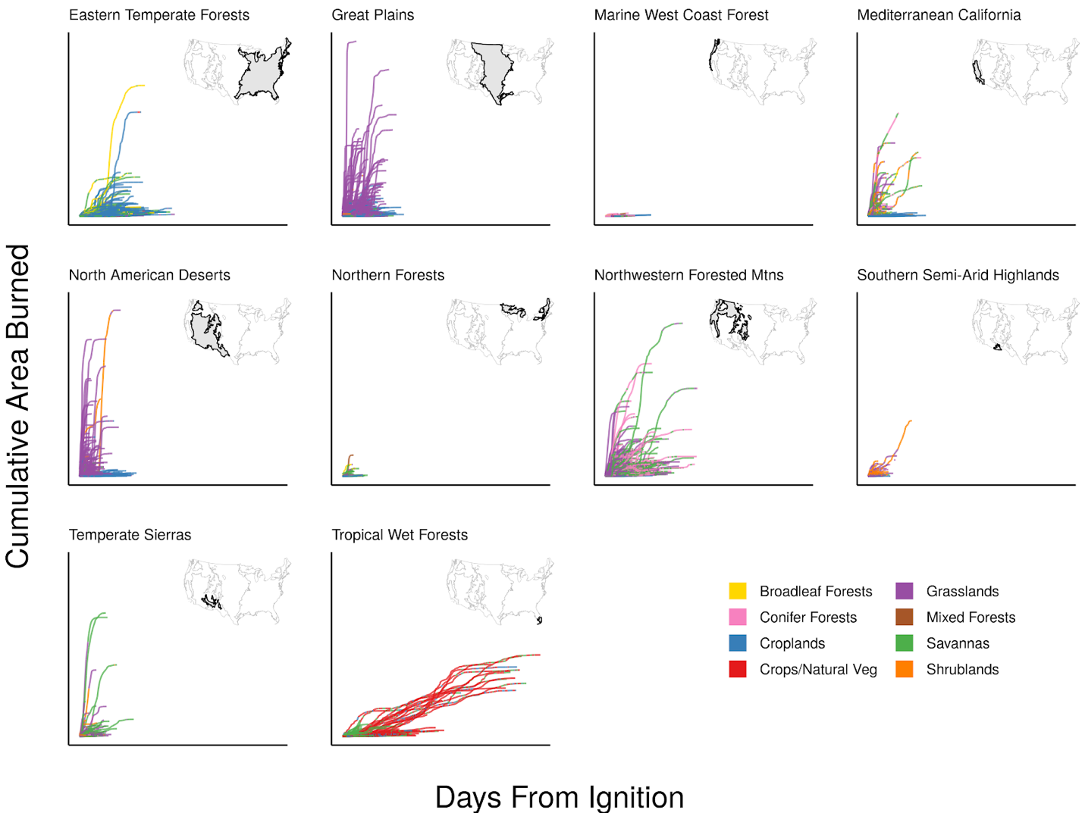

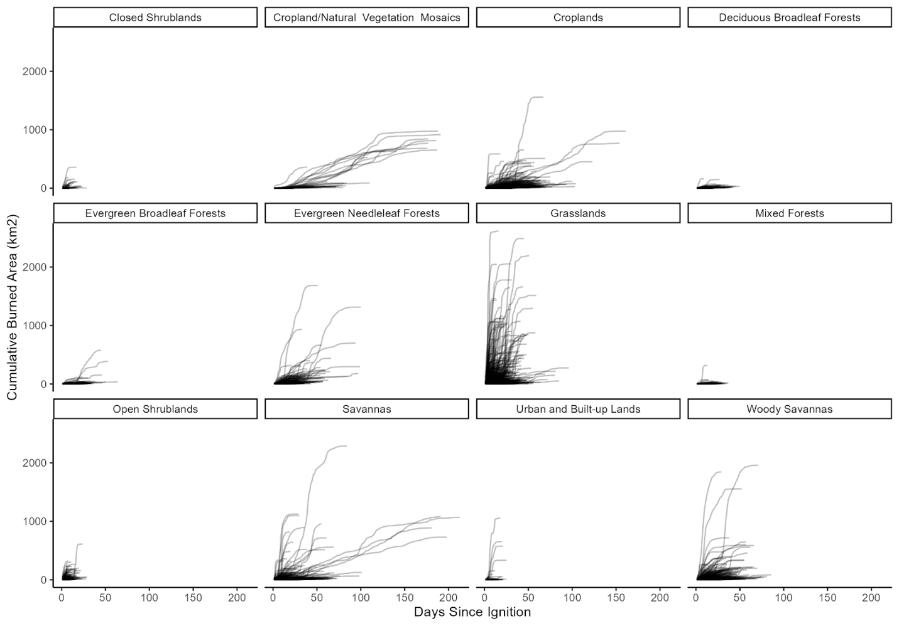

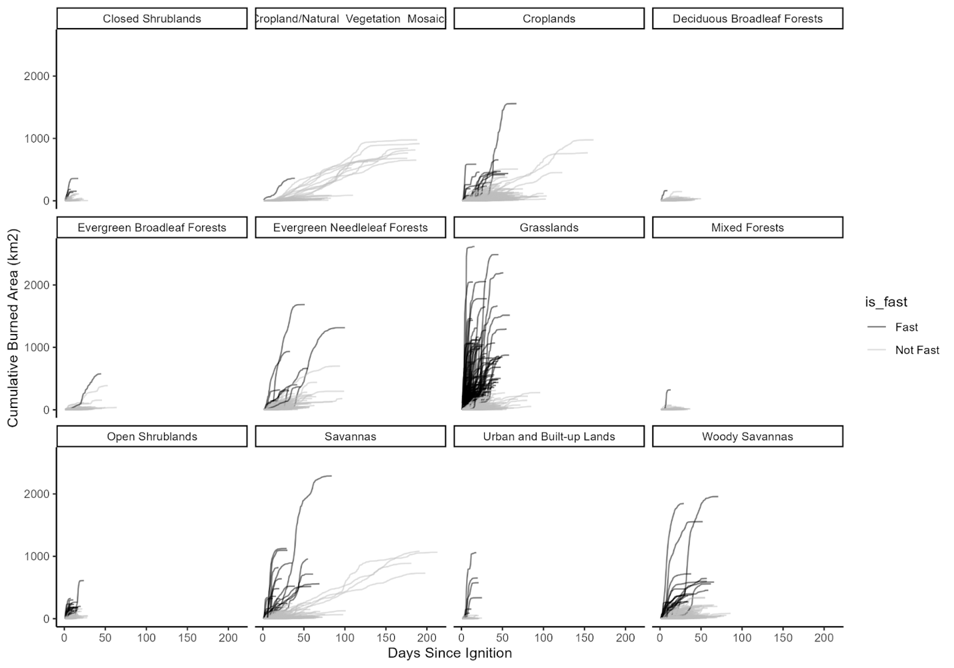

Figure SX???. Cumulative area burned by ecoregion and landcover. The time period immediately following ignition often has the most fire growth, but the variation in the day of extreme fire growth shows that there is not necessarily one critical period for management. We can see here in b, e and i that in grasslands and savannas, for many fires almost all of the burned area occurs in a few days. This can occur immediately after ignition, or in many cases pulses of rapid fire growth follow periods of little to no growth. For other landcover types, fires are typically slower growing.

**CUTS:**

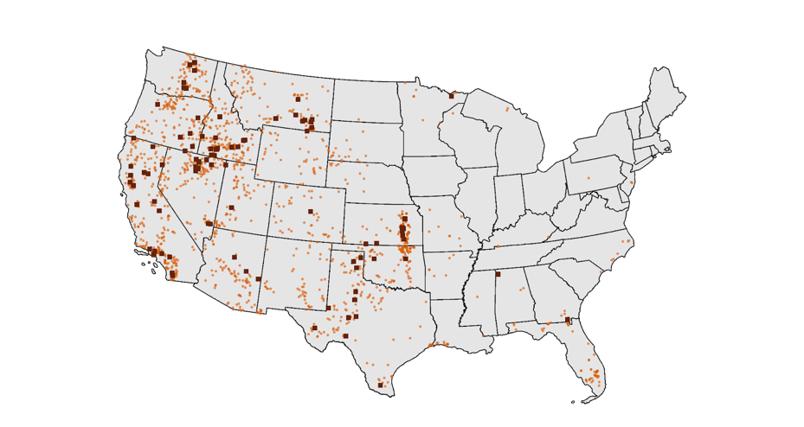

**Figure X** (Old figure from ICS209-PLUS (left), and time-series chart of the Rim fire using FIRED and HISDAC-US property records)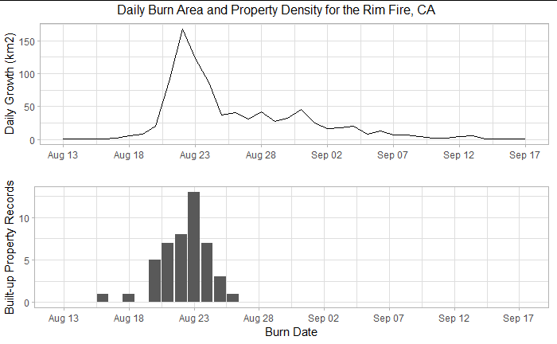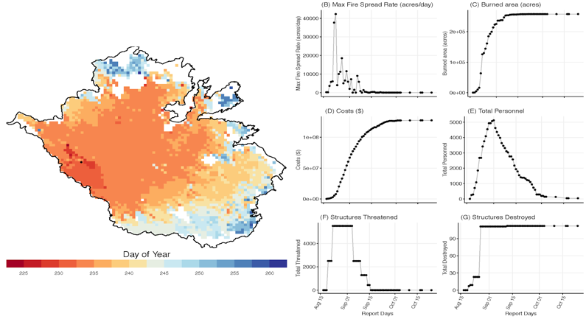

**Option 1**

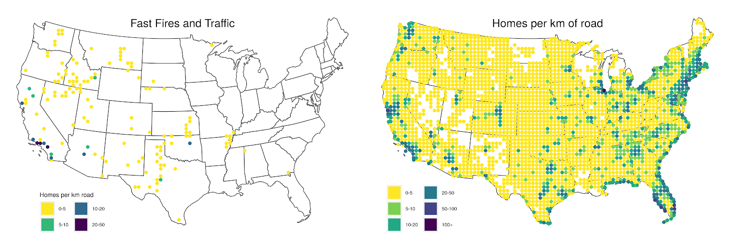

**Option 2**

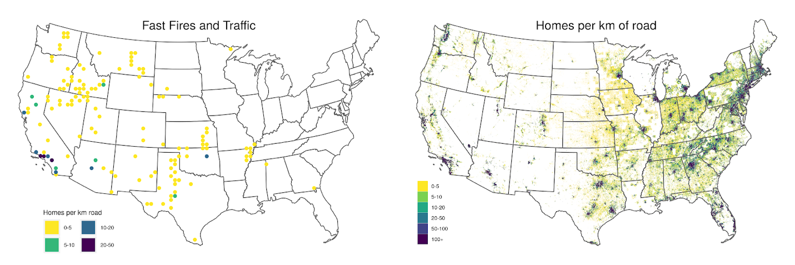

**Figure 4: a) and b).**

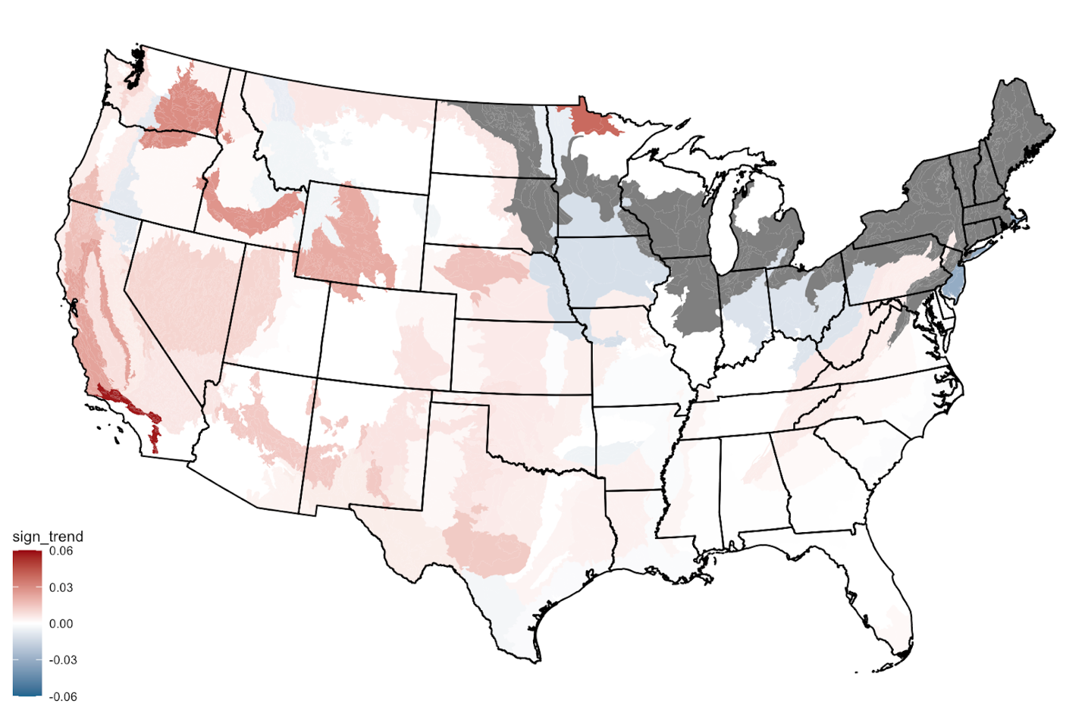

**Figure 3a:** Temporal trends in mean fire growth for events longer than four days per EPA ecoregion level IV (2001-2020). Statistically-significant positive and negative regression coefficients (p<0.05) are depicted in warm and cold colors, respectively. Regression coefficients that were not statistically significant from zero (i.e., no significant trend) are shown in white. Ecoregions without sufficient data for the analysis are indicated in gray.

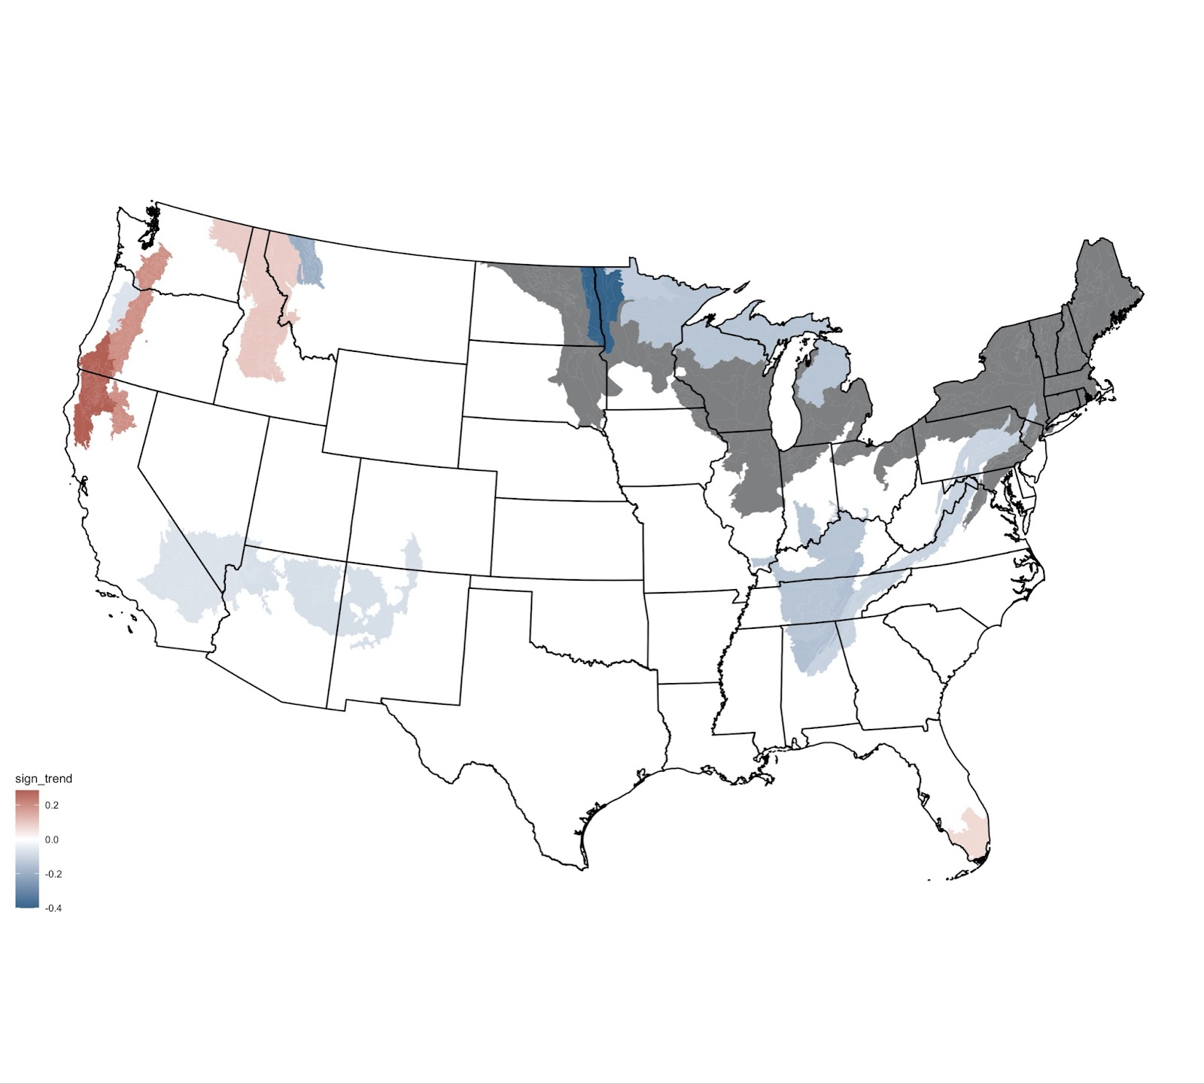

**Figure 3c:** Temporal trends in duration of events longer than four days per EPA ecoregion level IV (2001-2020). Statistically-significant positive and negative regression coefficients (p<0.05) are depicted in warm and cold colors, respectively. Regression coefficients that were not statistically significant from zero (i.e., no significant trend) are shown in white. Ecoregions without sufficient data for the analysis are indicated in gray.

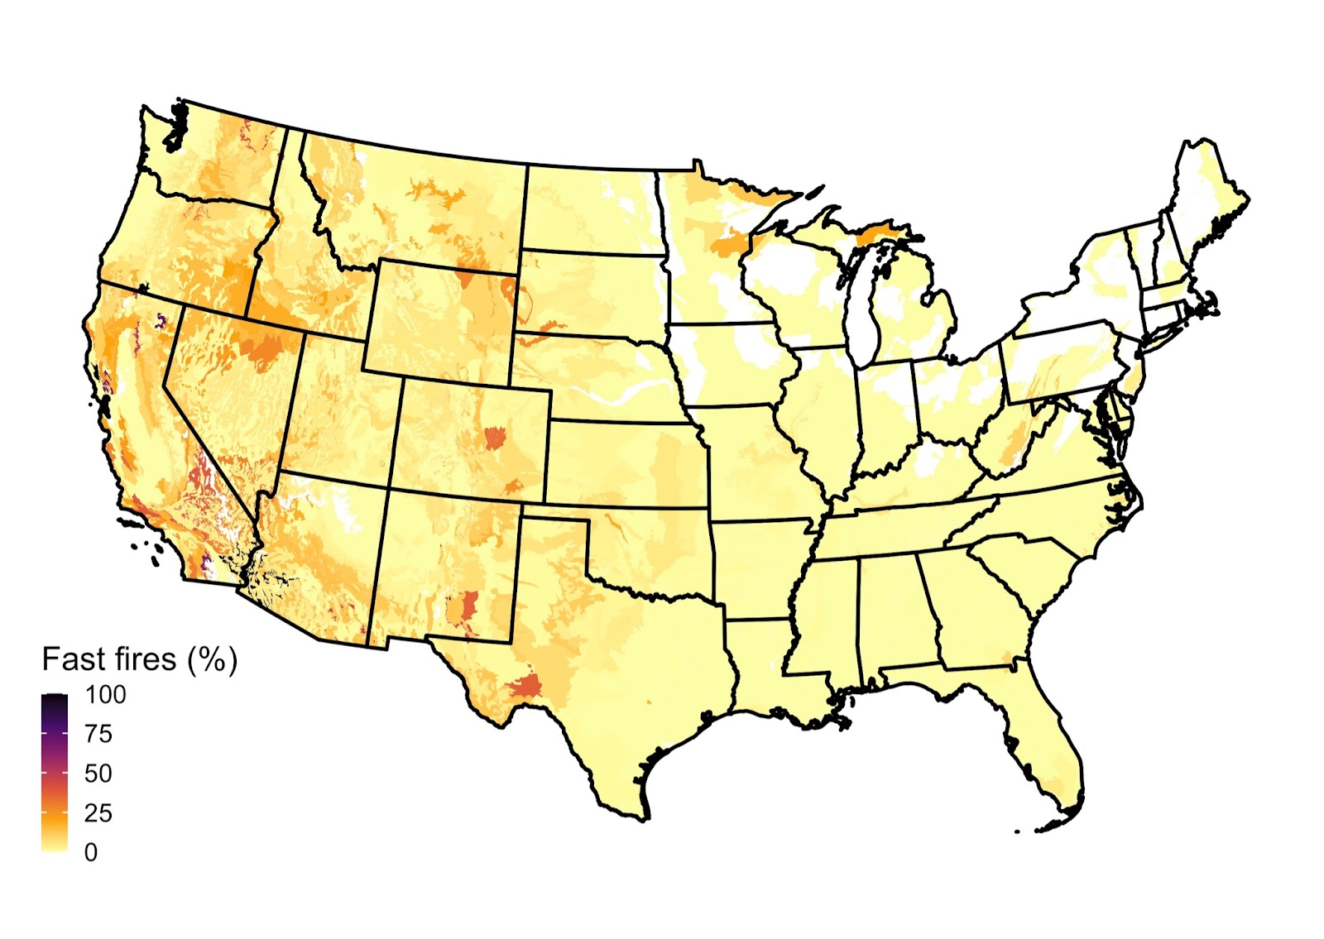

**Figure 4b:** Fast-to-total number of fires (>=1620ha/day) per EPA ecoregion level IV (2001-2020). Ecoregions that were not affected by fires in 2000-2020 are shown in white.

**NOTES & other stuff:**

By analyzing eco Within regions (explored at 0.5-degree cells, or approximately 50 km2) that experienced flash fires in combination with >200 million zillow records,, we also identify areas at 0.5-degree (~50 km2) spatial resolution that have potentially slow evacuation rates (20-50 homes/km of road) utilizing over 200 million housing records from Zillow.

CHARACTERISTICS BEING REPORTED OR COULD BE REPORTED (structure of the paper):

SPATIAL (where do they occur):

1. National density of fast fires (raw or percent of total fires or both?)
2. Fire growth rate vs societal impact (home losses and suppression costs)
3. FIre size versus spread rate (BUT see my note about the regressions below - they are not robust because of the clustering and single point outliers driving the high r2 and low p values)
4. Vegetation classes/ecoregion-level attributes (i.e., what veg do fast-fire dominate in)? Reported below but not stated here in the intro.

TEMPORAL (trends/time):

1. Trends in max growth rate over 20 years, by ecoregion
2. Duration: how much shorter are fast fires than slow fires - is it a huge duration difference? Probably need to stratify or compare by paired sizes to be fair - e.g., what is the duration difference between fast and slow 10-20k ha fires? Can potentially use the fire size classes from NIFC for the groupings to justify thresholds up to 2K ha (<https://www.nwcg.gov/term/glossary/size-class-of-fire>) then pick some step thresholds maybe?

GENERAL GROUPINGS:

1. Ignition source (human or lightning)?
   1. From the ICS-209-PLUS/FIRED link fires above the max growth threshold of 1620 ha (N=1,027); 23.27% human caused, 47.4% lightning caused, 27.36% unknown
2. Types of fast fires (long or short duration, where do fast growth days occur [beginning or middle]) by ecoregion

**Older stuff**

Within regions (defined by 0.5-degree cells, or approximately XXkm2) that experienced **flash fires, we also identify areas that have potentially slow evacuation rates** (20-50 homes/km of road) utilizing over 200 million housing records from Zillow. [How many homes have been exposed to fast wildfires? How many are in those regions? That are associated with high density, slow evacuations. And how are we going to define that.]

**Analysis:**

* **U.S. map of flash fires** (mean FSR); and by ecoregion; would love to see a gridded version of this; key point is that there are fast fires across ecoregions
* **Also Max FSR** plotted at a national scale - shows extremely fast fires & that they happen across ecosystems
* **Average FSR by year* (by ecoregion\***): Key point to see if there are trends, Are fires getting faster? Where are they getting faster? Spatially explicit, 1-degree representation of where fires are getting faster, is that robust?
* **Relationship between size and spread rate by ecoregion**. Key point: to demonstrate that there’s a relationship, but it does vary by ecoregion. (Relationship between speed & severity, if we bring in Mike’s algorithm)
* Look at seasonality? - another paper
* **Temporal trends by landcover**
* Land cover type only ~ time (plus latitude/elevation?)
* Max single growth day - NA out the small stuff, expand color gradient on big stuff
* **209 data bit**: relationship between FSR & deaths, homes threatened/destroyed, suppression costs; will need to swap in MODIS-derived FSR and match it with the impacts data in 209s; I’m envisioning a 3-panel figure for where we have a match between 209s & MODIS-derived events: a) deaths~MODIS-derived fire spread rate, b) homes threatened~MODIS-derived fire spread rate, c) homes destroyed~MODIS-derived fire spread rate. A fourth possible panel might be d) # of tweets/day for recent events where we collected as a function of MODIS-derived fire spread rate. (What are the physical fire characteristics of the most deadly? damaging? Expensive to suppress? Subset question here is: are they the fastest fires? Or what role do fast fires play in the societally disruptive wildfires?)
* **Hotspot detection of most vulnerable places**: overlay of fast fires and limited road networks that would constrict evacuation; cost distance analysis with housing density x road access; ratio of number of homes: road density, using recent fires as thresholds (this might be too hard right now, or not-ask Stefan); machine learning to predict future fire spread rates-Park’s idea (need to think about complex topography)
* Top ten of

**Future efforts:**

* What are the observed changes in winds, and are we seeing evidence for it in the fast fire record?
* Given this, we expect that wildfires would in general be occurring during higher wind conditions by virtue of the fact that people are starting more and more of our nation’s  wildfires, which are distributed throughout the year, and therefore the probability of coinciding with windier conditions is higher (we can test this). That’s a mouthful.
* Need to look at the speed distribution of events by ecoregion, looks like there are fast fires in all ecosystems no matter the vegetation type.
* Do we want to show the overlay of historical wind speeds & fuel moisture - or a fire danger rating system, seems obvious, but could be useful.
* Apply Lise’s algorithm to the BA ECV product, first appearance of events. We need the longer record to look at trends in spread rate.
* Empirical models, maximum tested wind speeds of  10 m/sec. How does that compare to maximum observed wind speeds during different wildfires?

Notes:

From Crystal: I think if you want to include the whole social/housing analsysis (and I don't think it is needed for the initial fast fires paper) the WUI or census data could be a potential substitute for housing data here. As we discussed on the last call, this idea of identifying "slow evacuation routes" is a tough one, although it is super important. I think simply attributing fast fires and describing patterns and trends is sufficient for this paper. But a quick and dirty approach would be to use WUI data from SILVIS, since it already incorporates census data, and identify the overlap between WUI and high frequency of fast fires, or to use the vulnerability data from either Davies et al. (2018) or Wigtil et al. (2016). I actually have the Wigtil data, as I contact Gabe several months ago and he kindly sent it to me.

https://journals.plos.org/plosone/article?id=10.1371/journal.pone.0205825#sec002

https://www.publish.csiro.au/wf/WF15109

* One consequence of larger fires is that the active fire line to suppress is longer, and with increased speed, more complicated to fight.
* Overlay of evacuation times and where the fastest fires have been? Or wind speeds?
* One key variable that has not been widely explored is fire spread rate:
  + Why?
  + What studies have explicitly modeled FSR? Or explored how or why it is changing?
  + RS offers the opportunity to calculate how fast fires are spreading across events
  + Mark Finney, mixed fuel landscape modeling
* for what species does event size actually matter? (Does size matter and for whom does it matter?)
* Have to account for the active fire line influencing the probable area of burn

FSR predictors paper, another piece: Amy’s leading this one

* Major predictors across the U.S. of fire spread rates (on an event basis)
* FSR~Day of burn by event: are there predictable patterns? (John and I talked about this at one point)

Key references:

* Billmire et al. 2014
* Sullivan 2009 (review of ROS models)
* Andela et al.
* Table of papers in data ms

Other recent work:

* Liu et al (2018) use remote sensing data from a new satellite that has 0.5km pixels at  10 minute temporal resolution to calculate fire spread (It’s a geostationary Japonese satellite so no applicable for U.S.)
* Benali et al (2018). “Uncertainty in input variables was propagated throughout the modeling framework ... for eight very large wildfires in Portugal. Results showed that uncertainties in **wind speed and direction**, **fuel model assignment** and typology, location and timing of ignitions, had a major impact on prediction accuracy.”
* Alexander et al (2013): Highlight the need for “Model evaluation based on field observations and measurements of free-burning fires across a range of fuel types and fireline” in the new generation of physics-based models of fire spread
* Rossa et al (2017): (from abstract)
  + Main results: In a typical Mediterranean shrubland, laboratory and field-derived FMC damping functions are linearly related, which is explained by the correlation between monthly average live and dead FMC variation throughout the year. This clarifies why the effect of live FMC on real-world fires ROS has remained elusive, although in fact it has an influence.
  + Research highlights: By providing evidence that **the most significant effect of FMC on ROS is independent of vegetation phenology (dead or live condition),** and explaining why **in specific situations dead FMC is sufficient to provide satisfactory ROS predictions**, our results can assist future modelling efforts.
* Cruz 2015: reviews 22 fire spread models for australian fuel types, highlights key advances relating wind speed to fire spread:
  + “early modelling approaches relied on an exponential function to describe the wind effect on fire spread rate. Although this function predicted results well for low to moder- ate winds, at the higher end of the wind speed spectrum it resulted in fallaciously high rates of fire spread. In some cases, models of this form will result in predicted rates of fire spread higher than the input wind speed. Most of the models developed after the mid-1990s implemented a power function with an exponent close to 1.0 to describe the effect of wind speed.”
  + “formal recognition of a wind speed threshold below which rate of fire spread is inconsistent (e.g. Burrows 1994 first reported an eye-level wind speed threshold of 3–3.5 km h–1 in forest stands) or, in discontinuous fuel types, non-existent (Gill et al. 1995)”.
* Swamp effect of the small events; especially if the fastest fires are large
* Parsing this analysis by size class, weighting the fires by size
* What does the distribution of fire size look like on an annual basis? Is that distribution changing? If it is, then we might be capturing the FSR average of the smallest events, rather than a change in FSR in the large events.
* Do we need this trend analysis?
* Are the extremes changing?
* Max. daily growth rate.
* Annual total burned area ~ annual mean FSR

References:

Alexander, M. E., & Cruz, M. G. (2013). Are the applications of wildland fire behaviour models getting ahead of their evaluation again? Environmental Modelling and Software, 41, 65–71. <https://doi.org/10.1016/j.envsoft.2012.11.001>

Andrews P (1986) BEHAVE: fire behaviour prediction and fuel modelling system – BURN subsystem, Part 1. USDA Forest Service, Intermountain Forest and Range Experiment Station, General Technical Report INT-194. (Ogden, UT)

Beer T (1991) The interaction of wind and fire. Boundary-Layer Meteorology  54(2), 287–308.   
  
Beer T (1993) The speed of a fire front and its dependence on wind speed. International Journal of Wildland Fire  3(4), 193–202.   
  
Beer T (1995) Fire propagation in vertical stick arrays: the effects of wind. International Journal of Wildland Fire  5(1), 43–49.

Benali, A., Ervilha, A. R., Sá, A. C. L., Fernandes, P. M., Pinto, R. M. S., Trigo, R. M., & Pereira, J. M. C. (2016). Deciphering the impact of uncertainty on the accuracy of large wildfire spread simulations. Science of the Total Environment, 569–570, 73–85. <https://doi.org/10.1016/j.scitotenv.2016.06.112>

Billmire, M., French, N. H. F., Loboda, T., Owen, R. C., & Tyner, M. (2014). Santa Ana winds and predictors of wildfire progression in southern California. International Journal of Wildland Fire, 23(8), 1119. <https://doi.org/10.1071/wf13046>

Bradstock R , Gill A (1993) Fire in semiarid, mallee shrublands – size of flames from discrete fuel arrays and their role in the spread of fire. *International Journal of Wildland Fire* **3**(1), 3–12.

Byram GM (1966) Scaling laws for modeling mass fires. *Pyrodynamics* **4**, 271–284.

Carrier G, Fendell F , Wolff M (1991) Wind-aided firespread across arrays of discrete fuel elements. I. Theory. *Combustion Science and Technology* **75**, 31–51.

Catchpole WR, Catchpole EA, Butler BW, Rothermel RC, Morris GA , Latham DJ (1998*b*) Rate of spread of free-burning fires in woody fuels in a wind tunnel. *Combustion Science and Technology* **131**, 1–37.

Chandler C, Cheney P, Thomas P, Trabaud L, Williams D (1983) ‘Fire in Forestry 2: Forest Fire Management and Organization.’ (Wiley: New York)

Cheney, N. P., Gould, J. S., & Catchpole, W. R. (1993). The Influence Of Fuel, Weather And Fire Shape Variables On Fire-Spread In Grasslands. International Journal of Wildland Fire, 3(1), 31–44. <https://doi.org/10.1071/WF9930031>

Cheney NP , Gould JS (1995) Fire growth in grassland fuels. *International Journal of Wildland Fire* **5**, 237–247.

Cheney NP, Gould JS , Catchpole WR (1998) Prediction of fire spread in grasslands. *International Journal of Wildland Fire* **8**(1), 1–13.

Cruz, M. G., & Alexander, M. E. (2013). Uncertainty associated with model predictions of surface and crown fire rates of spread. Environmental Modelling and Software, 47, 16–28. <https://doi.org/10.1016/j.envsoft.2013.04.004>

Cruz, M. G., Gould, J. S., Alexander, M. E., Sullivan, A. L., McCaw, W. L., & Matthews, S. (2015). Empirical-based models for predicting head-fire rate of spread in Australian fuel types. Australian Forestry, 78(3), 118–158. <https://doi.org/10.1080/00049158.2015.1055063>

Curry JR , Fons WL (1938) Rate of spread of surface fires in the Ponderosa pine type of California. *Journal of Agricultural Research* **57**(4), 239–267.

Dowdy, A. J., Ye, H., Pepler, A., Thatcher, M., Osbrough, S. L., Evans, J. P., ... & McCarthy, N. (2019). Future changes in extreme weather and pyroconvection risk factors for Australian wildfires. Scientific reports, 9(1), 1-11.

Fendell FE, Wolff MF (2001) Wind-aided fire spread. In ‘Forest Fires: Behaviour and Ecological Effects’, 1st edn. (Eds E Johnson, K Miyanishi) Ch. 6, pp. 171–223. (Academic Press: San Diego, CA)

Linn RR , Cunningham P (2005) Numerical simulations of grass fires using a coupled atmosphere–fire model: basic fire behavior and dependence on wind speed. *Journal of Geophysical Research* **110**, D13107.

Liu, X., He, B., Quan, X., Yebra, M., Qiu, S., Yin, C., … Zhang, H. (2018). Near Real-Time Extracting Wildfire Spread Rate from Himawari-8 Satellite Data. Remote Sensing, 10(10), 1654. <https://doi.org/10.3390/rs10101654>

Massada, A. B., Radeloff, V. C., Stewart, S. I., & Hawbaker, T. J. (2009). Wildfire risk in the wildland–urban interface: a simulation study in northwestern Wisconsin. *Forest Ecology and Management*, *258*(9), 1990-1999.

Nelson RM (2002) An effective wind speed for models of fire spread. *International Journal of Wildland Fire* **11**(2), 153–161.

Perry GLW (1998) Current approaches to modelling the spread of wildland fire: a review. Progress in Physical Geography  22(2), 222–245.   
  
Pitts WM (1991) Wind effects on fires. Progress in Energy and Combustion Science  17(2), 83–134.

Rothermel RC (1972) A mathematical model for predicting fire spread in wildland fuels. USDA Forest Service, Intermountain Forest and Range Experimental Station, Research Paper INT-115. (Odgen, UT)

Sullivan AL (2009a) Wildland surface fire spread modelling, 1990–2007. 1: Physical and quasi-physical models. *International Journal of Wildland Fire* **18**, 349–368.

Sullivan, A. L. (2009b). Wildland surface fire spread modelling, 1990 - 2007. 2: Empirical and quasi-empirical models. International Journal of Wildland Fire, **18**, 369–386. https://doi.org/10.1071/wf06142

Thomas PH (1967) Some aspects of the growth and spread of fire in the open. *Journal of Forestry* **40**, 139–164.

Van Wagner CE (1977*a*) Conditions for the start and spread of crown fire. *Canadian Journal of Forest Research* **7**(1), 23–24.

Van Wagner CE (1977*b*) Effect of slope on fire spread rate. *Canadian Forestry Service Bi-Monthly Research Notes* **33**, 7–8.

Viegas DX (2004) A mathematical model for forest fires blowup. *Combustion Science and Technology* **177**(1), 27–51.

theil sen

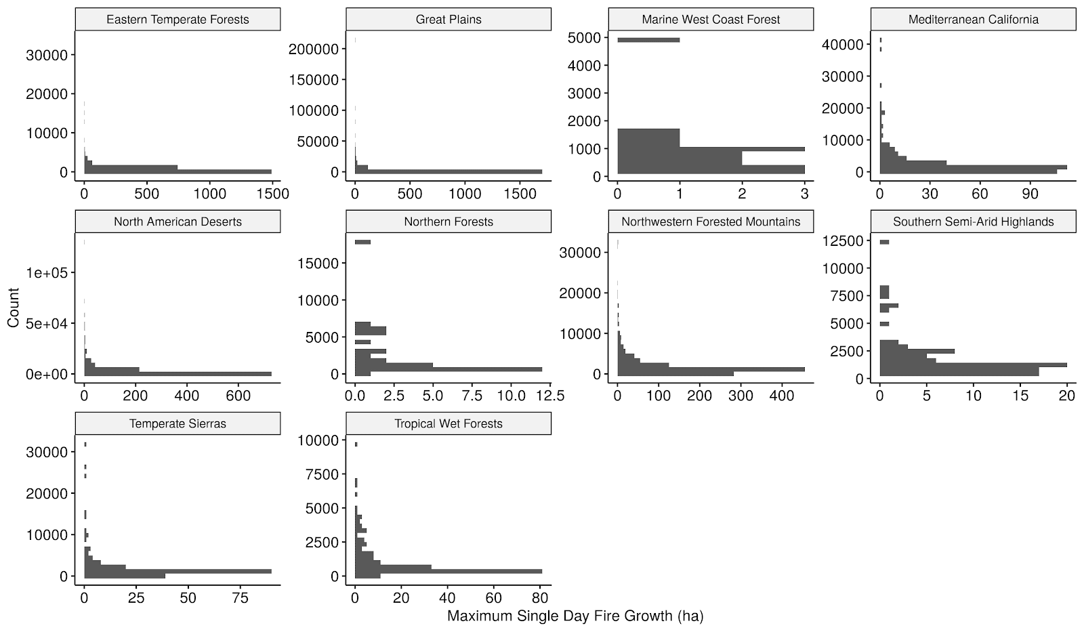

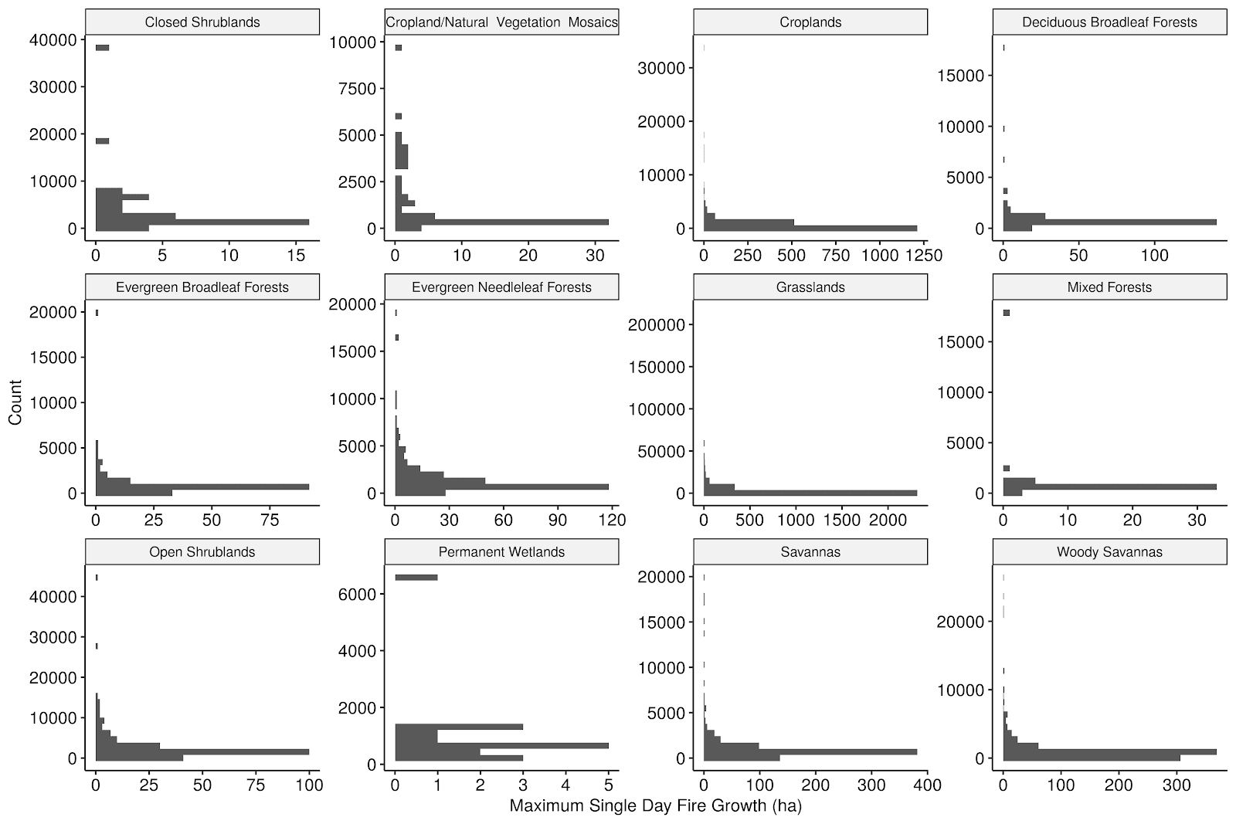

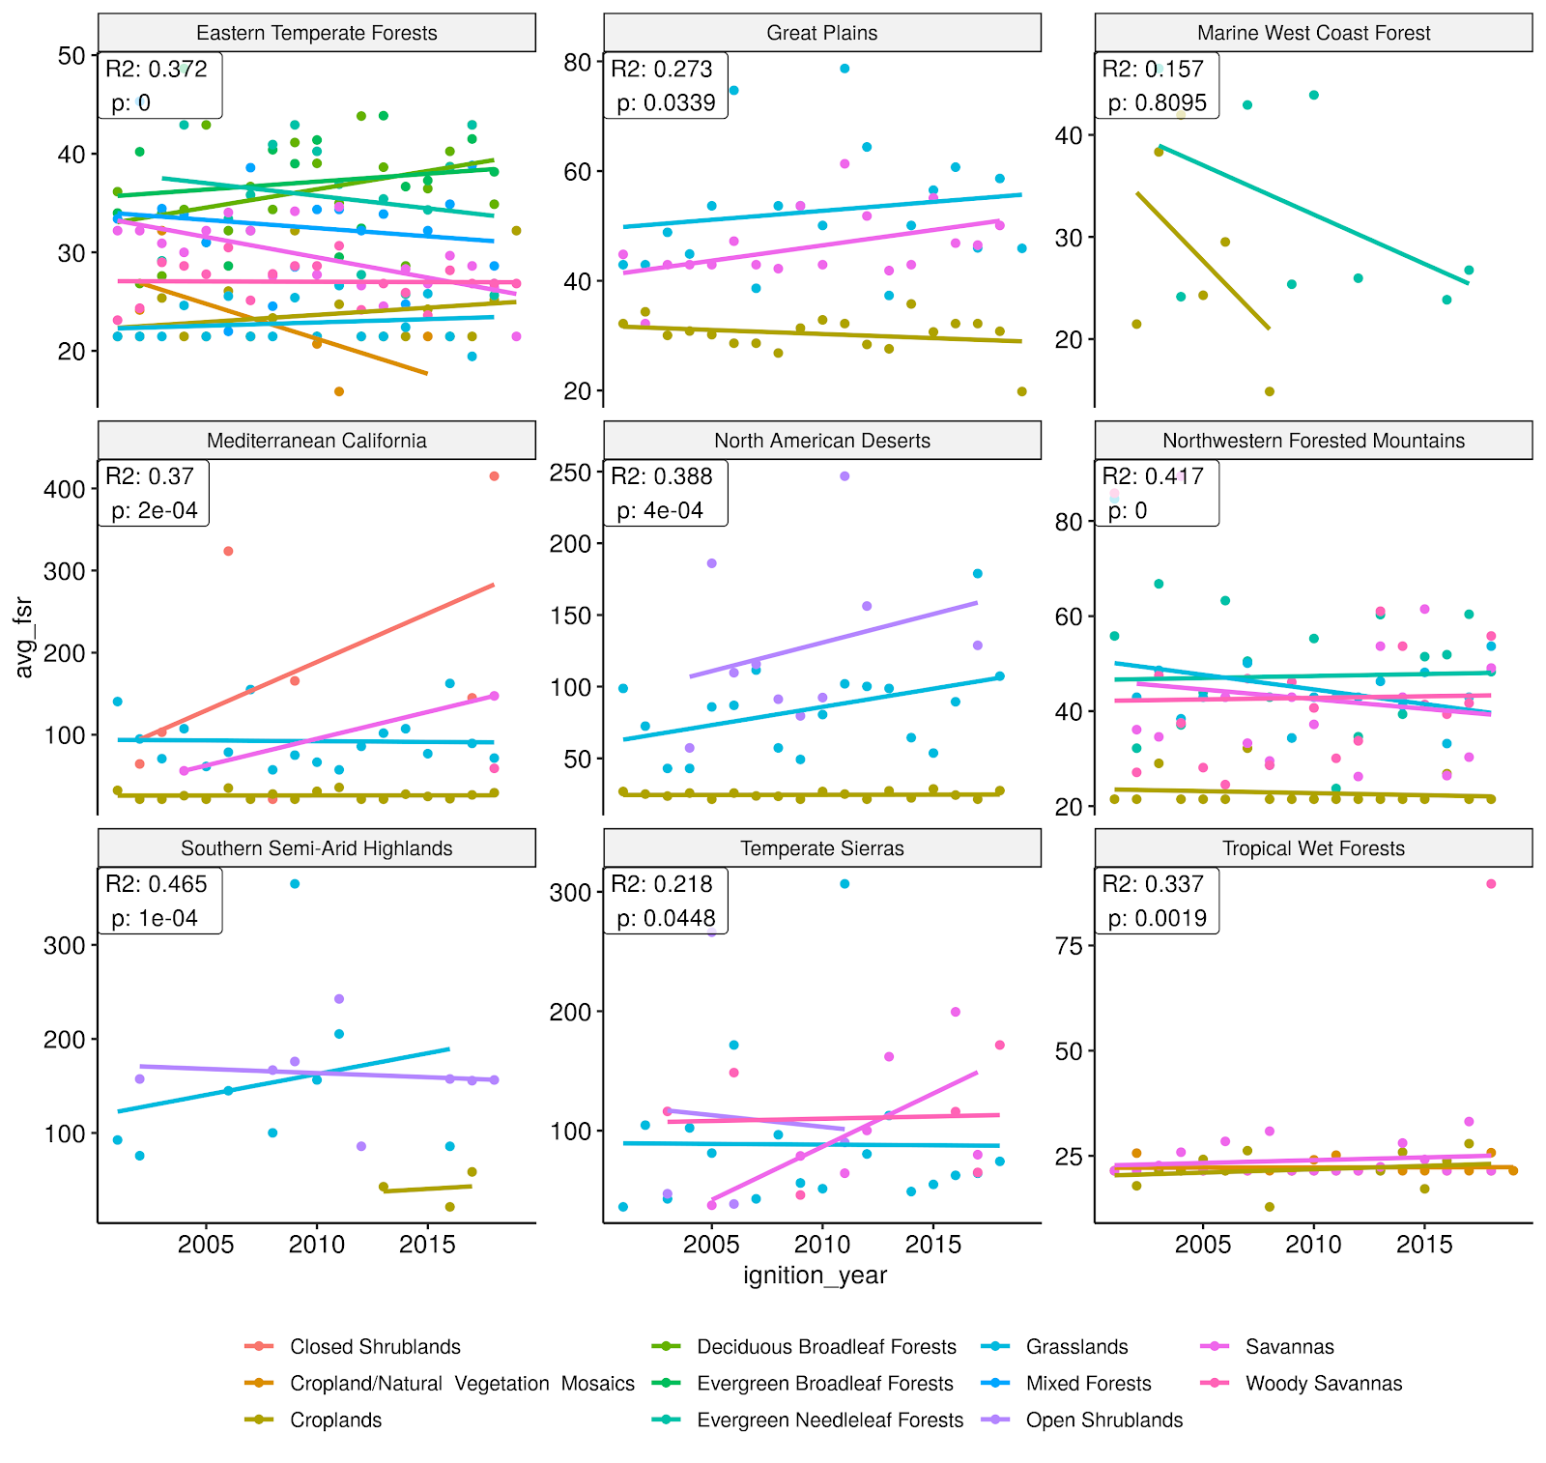

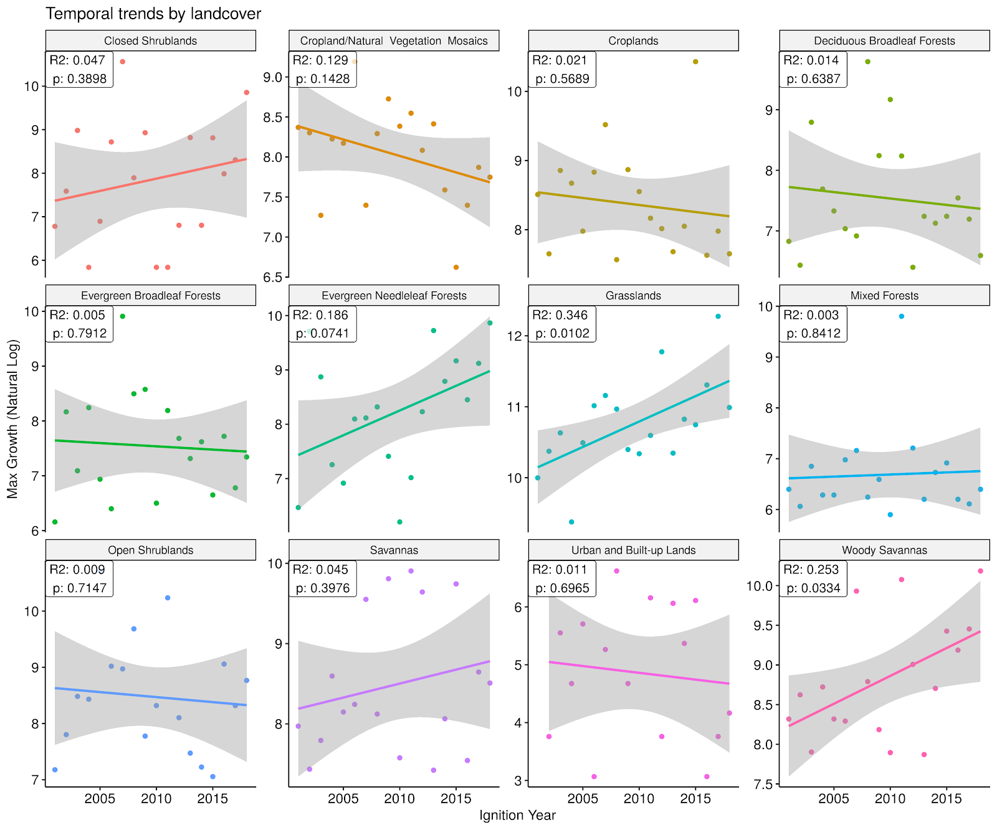

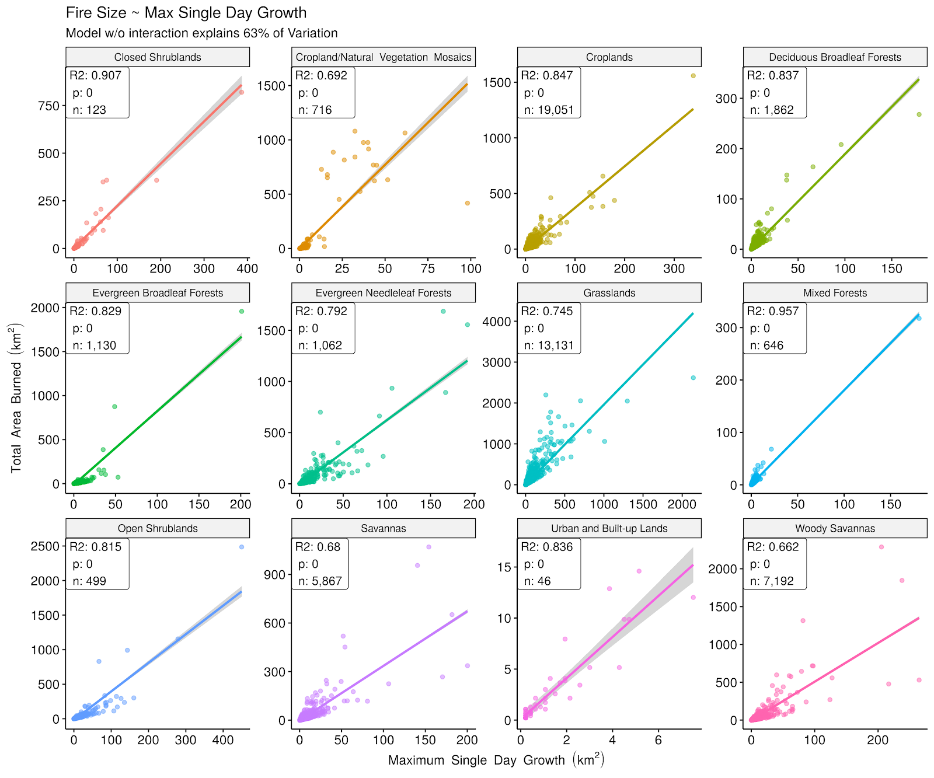

CUTS:

What do we expect would drive fast fires?

* Fine scale understanding and modeling of fire spread, rate of spread models; lots of wildland fire simulation of spread
* Loads of work has been done in generally three categories: landscape fire simulations for individual events, the physics and chemistry of biomass combustion, and empirical models that derive relationships to predict fire spread.
* A review of surface fire spread models developed over the past couple decades maintains **wind speed** and **fuel moisture** as the major driving variables in determining fire spread (Sullivan et al. 2009b - the second in the series).
* We also know that **grass-fueled fires** can be fast, given the high surface area:volume ratio. Is there anything besides anecdote to support this (Cheney 1993)?
* Empirical models generally demonstrate an exponential relationship (but not all) between fire spread rate and wind speed (Sullivan 2009b), but have only been derived under high, but not extreme, wind conditions (maximum of 10 m/sec; how does that compare to maximum observed wind speeds during different wildfires?).
* Given this knowledge base, we would expect the fastest wildfires to be driven by one or more of the following: (also see figure 2 from cruz & alexander (2013))
  + high winds
  + dry and hot conditions (i.e. low fuel moisture)
  + greater slope conditions which increases fuel availability (but is this important at larger scales)
  + light/flammable fuels (fuel moisture becomes drier faster)
    - I.e. grasslands, shrublands

* The two most important variables in modelling FS are wind speed and Fuel moisture content (Sullivan 2009b). Fuel aridity is steadily increasing due to climate change (Abatzaglou et al 2016), while wind is less predicable.
* While much is known about the empirical relationship between climate & fuel variables and fire spread, particularly at fine scales and in controlled lab environments (refs), not much effort has focused on understanding how fast fires are and what drives the rate of movement at large regional scales. This is a critical blind spot in fire science.
* Approaches and methods range from physical, theoretical understanding of the physics and chemistry of combustion of biomass (refs) to empirical models relating fire spread to WRF fire models that try and help with real-time fire management efforts. But lacking has been….said above.
* The immediate need to understand a moving flame front during active suppression efforts has driven early and continued efforts to understand the direction and rate of fire spread (e.g., Chandler et al. 1983). The Rothermel (1972) equation, which is the foundation for the National Fire Danger Rating System (Deeming et al. 1977; Burgan 1988) and the fire behaviour

prediction tool BEHAVE (Andrews 1986), is an early part of this lineage.

* And then there are extremes? Are we seeing more extreme wildfires? What is the understanding of what drives blow-ups (e.g., Yarnell Hill fire, fire whirls)?  There are anecdotally events that seem to be operating under different drivers, calling for new approaches to how we understand, model, and predict extremes (Joseph et al. 2019).
* It also might be good to talk about the management issue, with people calling for more forest thinning, etc, while many of the fastest fires are not occurring in forest…
* Also, cite research about ponderosa pine forests, for example,  not having enough ponderosa pine regeneration under recent climate change, arguing that ecosystems will convert to dryer and more flammable systems (grasslands, shrublands), which are also systems with faster fire. Also examples with P-J and sagebrush

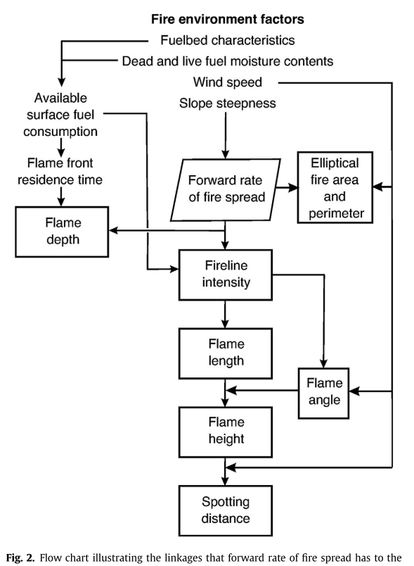

Potential Case study figure: Martin fire, 4 days, 450,000 acres

